User Manual: Accounts Payable

| july-20 |

**Document Overview**

**Documentation Goals**

This documentation is intended to provide instruction for all ***Accounts Payable*** functions. It details the use of ***Invoices, Credit and Debit Memos, Payments, Check Processing, and Vendor Maintenance.***

**Documentation Disclaimers**

* Teach a user how to utilize The Accounts Payables and Voucher system.
* Provide instructions for processing transactions and keeping track of Vendor balances.

**Table of Contents**

**Overview of Advantzware Specific Keys and Icons** 5

Function Keys 5

Advanced Software Standard Function Keys 6

Program Icons 7

**Accounts Payable Overview** 8

**Update/Enter Vendor Invoices [VU]** 9

Overview 9

Enter/Edit AP Invoices [VU1] 9

Add/Update Invoice 12

Add/Update Invoice Line 14

Enter/Edit Recurring AP Invoices [VU2] 16

Add/Update Invoice 18

Add/Update Invoice Line 20

Load Invoices 22

AP Invoice Posting [VU3] 23

**Write AP Credit/Debit Memos [VW]** 25

Overview 25

Add/Edit DB/CR Memos [VW1] 25

Add/Update Memo 27

Debit/Credit Register [VW2] 30

**Build Payment Selection List [VB]** 31

Overview 31

Select by Due Date [VB1] 31

Overview 31

Add/Update Due Date 33

Select by Vendor [VB2] 35

Selection Register [VB3] 36

**Check Processing [VC]** 38

Overview 38

Print AP Checks [VC1] 38

Manual Checks [VC2] 40

Browse Checks 40

Add/Update Check 42

Check Register [VC3] 44

Void AP Checks [VC4] 46

Update Check 48

Voided Check Register [VC5] 49

**Track Bank Reconciliation [VT]** 50

Overview 50

Bank Reconciliation [VT1] 50

Reconciliation Register [VT2] 52

Reconciliation Report [VT3] 53

Load Reconciliation File [VT4] 54

**List Cash Disbursements [VL]** 55

Enter/Edit Disbursements [VL1] 55

Overview 55

Browse Disbursements 55

Add/Update Disbursement 57

Add/Update Disbursement Line 59

Disbursements Register [VL2] 61

Check Register Import [VL3] 62

**Query Accounts Payable [VQ]** 63

Invoice Balances [VQ1] 63

Check Invoices [VQ2] 64

AP Credit/Debit Memos [VQ3] 65

Browse CR/DB 65

AP Invoice Inquiry [VQ4] 67

Browse Invoices 67

View Invoices 68

**Reports for Payables [VR]** 69

Overview 69

Vendor Aging [VR1] 70

AR Cash Requirements [VR2] 73

AP Vendor Analysis [VR3] 76

Vendor Master List [VR4] 78

AP Mailing List [VR5] 80

Monthly Tax [VR6] 83

Tax Distribution Schedule [VR7] 84

MTD Destination Subtotals [VR8] 86

Tax Schedule by Customer [VR9] 88

Vendor 1099 Report [VR)] 90

AP Accounts by Vendor [VR!] 92

AP Invoices by Vendor [VR@] 94

AP Check Register [VR#] 96

1099 Miscellaneous [VR$] 99

Check Register by GL Number [VR%] 100

**File Maintenance for Vendors [VF]** 102

Overview 102

Vendors [VF1] 103

Add/Update Vendor 106

Totals 110

Add/Update Total 111

API/EDI 113

Add/Update API/EDI 114

Vendor Types [VF4] 115

Browse Types 115

Add/Update Type 117

Buyers [VF5] 118

Browse Buyers 118

Add/Update Buyer 120

Accounts Payable Control [VF6] 121

Update Control 121

Payment Type [VF7] 123

Browse Types 123

Add/Update Type 125

# **Overview of Advantzware Specific Keys and Icons**

## Function Keys

|  |  |
| --- | --- |
| BRWS | The browser, which is a list of records in this file. This is functionally equivalent to the Find option of our standard package. |
| VIEW | View record provides the ability to ADD, CHANGE, DELETE, and UPDATE an individual record. |
| SORT BY | The selections at the bottom of the browser, which will sort the list alphabetic order. |
|  |  |
| Update | Update the current record. |
| Reset | Reset the current record. |
| Add | Add a record. |
| Copy | This will copy the existing record. |
| Delete | Delete the current record displayed on the screen. |
| Cancel | Cancel the information that was entered. |
| Save | Save the record. |
|  |  |
|  | Takes the user to the first current record. |
|  | Moves backward one record. |
|  | Moves forward one record. |
|  | Takes the user to the last current record. |
|  |  |
| F1 | Miscellaneous Fields |
| F3 | Search |
| F3 | List |
| F4 | Notes |
| F6 | Browse |
| F7 | Viewer |
| F12 | Exit |

## Advanced Software Standard Function Keys

|  |  |
| --- | --- |
| Next | Shows the next sequential record. |
| Prev | Shows the previous record. |
| Add | Add a record. |
| Change | Change the current record displayed on the screen. |
| Delete | Delete the current record displayed on the screen. |
| Find | Find a record by searching by description. |
| “1”, “2” | Number 1 or 2 to go the first or second page of this record. |
| Esc | Escape from the current transaction without updating. |
| Q | Quit from the current transaction without updating. |
| F1 | Save |
| F3 | Help information is available on every data field. Simply place the cursor on a field and press F3 to display documentation regarding this particular field. |
| F3 | To insert additional data in a data field without erasing the information currently displayed. |
| F4 | Notes – General |
| F1 | Field Lookup is available on every data field which is maintained in a separate file. Place the cursor on a field and press ***“F1”*** to search for the code by description or to advance a screen of records by pressing the next key. Place the cursor next to the desired record and press enter to transfer the record to the data entry screen. See ***“Page Up”*** / ***“Page Down”*** keys below as an alternative |
| F7 | Delete |
| F8 | Notes – File Specific |
| Enter | Advances the cursor to the next field |
| Page Up | Will skim forward through each record in a data file in sequential order |
| Page Down | Will skim backward through each record in a data file in sequential order |
|  |  |

## Program Icons

|  |  |  |
| --- | --- | --- |
|  | Job Notes |  |
|  | Customer Attachments | Attach files (such as Word/Excel/Images) for this specific customer order. |
|  | Change Move/Set Column Mode |  |
|  | Print Acknowledgement |  |
|  | Export to Excel |  |
|  | Add |  |
|  | Attachments | Attachments for this Estimate. Will transfer to all future repeat orders for this estimate. |
|  | Notes |  |
|  | Spec Notes | Notes for specific finished goods items. |
|  | Utility Application |  |
|  | Help |  |
|  | UDF Viewer |  |
|  | Commissions |  |
|  | Exit |  |
|  |  |  |
|  |  |  |

# **Accounts Payable Overview**

The Accounts Payable (A/P) module is integrated with Purchasing. Simply enter the PO Number when adding a Vendor Invoice and all of the pricing information will transfer to the screen.

Payment vouchers for the invoice are created and a check is then created in A/P upon posting. Manual Checks are also an option in the module. In the Raw Materials file, the quantity received automatically updates the quantity on hand, and decrements the quantity on order. The Accounts Payable application maintains the vendor master file and records all the company's expenses posting them by way of a direct interface to the General Ledger system.

The Accounts Payable module supports multiple bank accounts, manual checks, as well as the printing of computer checks. There are numerous reports available including the purchase journal, aged Accounts Payable, check register, cash requirements, vendor analysis, month end check register and bank reconciliation.

An audit trail report, to ensure data integrity, is produced when adding, deleting or maintaining information by vendor. The vendor file prints in alphabetic order by a range of vendors. Vouchers and payments automatically track purchases and cost period-to-date and year-to-date, highest balance due, average days to pay, last payment amount and date and total payments.

When first implementing the Accounts Payable module, the purchasing expense accounts numbers must be entered in the General Ledger chart of accounts maintenance file. A default General Ledger expense account is assigned to each vendor to help speed data entry process. Vendor invoices entered are accrued by the system for posting to the General Ledger. The accounting period, selected by the operator, will record all expenses.

The edit/posting register will print a listing of the most recently entered A/P invoice batch. It will then allow you to update this batch to the General Ledger. You may print an aging report for all invoices that have been entered providing vendor and company totals. An inquiry is also available to display open invoices by vendor.

Payment selection is available by Due Date, and by Vendor Number. The selection of individual invoices is done after the Vendor is chosen. Manual checks and cash disbursements are also supported. Once invoices have been selected, the payment selection register summarizes all the invoices selected for payment, allowing for additions or deletions. After the printing of the checks is complete, a check register is printed, and lastly, the posting of the transactions. A summary of all the transactions transfers to the General Ledger after the operator chooses the option to post the transactions.

At the end of the accounting period, print the Month End Check Register. This is an accumulation of all the checks printed during this accounting period. Upon completion of this report, you will have the option to purge this report file from the system. The bank reconciliation function will assist in the reconciliation of bank and book cash balances.

# **Update/Enter Vendor Invoices [VU]**

## Overview

The Invoices Menu gives the options of Adding and Editing Invoices, and Printing the Edit Register. You can add Vendor Invoices on the first screen. After they are added, you should print an Edit Register to check for data entry errors, etc. Once all corrections are made and you are satisfied with the Invoices, you can post them from the Print Edit Register screen, and it will update all vendor and general ledger files. Once posted, you are unable to go back and make changes to the vendor invoices. If you choose not to Post them, the system will not update the records.

## Enter/Edit AP Invoices [VU1]

This program is used to enter any invoices your company receives from a vendor. Once the vendor invoices have been entered and posted, the invoice amounts will be transferred to the General Ledger Accounts Payable account. This program is also used to inquire (or look at) a previously entered invoice.

### Browse Invoices

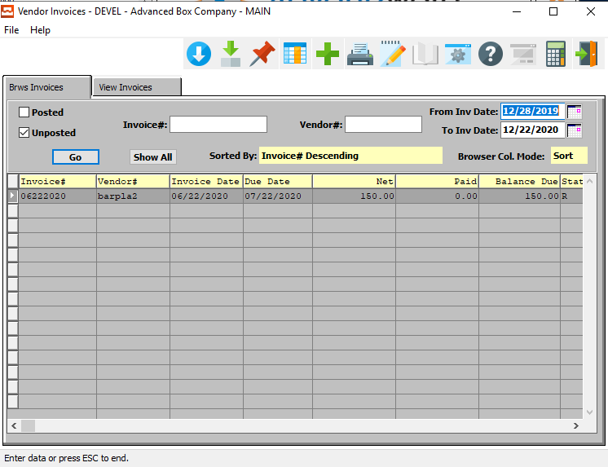

#### ADD

Click the ***“Green + Icon”*** to add a new AP Invoice.

### Browse Invoices Field Definitions

#### Posted – Toggle Box

To search for Posted AP Invoices, make sure that the Posted toggle box is checked.

#### Unposted – Toggle Box

To search for Unposted AP Invoices, make sure that the Unposted toggle box is checked.

#### Invoice #

This field is only used if a Purchase Order has been entered for this vendor through Purchase Order Processing. The Invoice number has to be unique for this vendor (two vendors can have the same invoice number, but one vendor can't use the same invoice number more than once).

#### Vendor #

Enter the vendor number and press the enter key to use this vendor. Press the ***“F1”*** function key to search and press ***“Enter”*** on selected vendor, press the ***“Page Up” or “Page Down”*** keys to scroll through vendors or enter the first few letters in the vendor’s name and press ***“Enter”***.

#### From Invoice Date / To Invoice Date

Enter the beginning and ending Invoice Date to search between.

### View Invoices

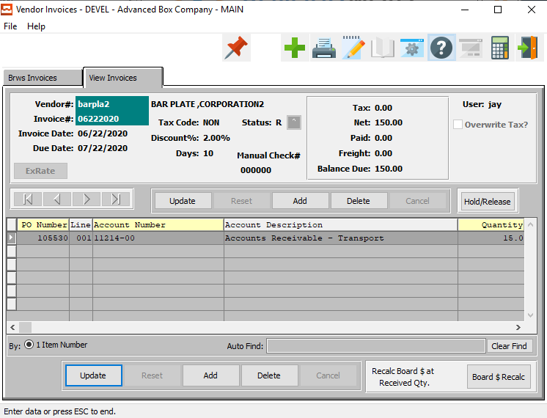

#### UPDATE

To change the currently selected AP Invoice, simply click the ***“Update***” button in the middle of the screen.

#### ADD

To add a new AP Invoice, simply click the ***“Green + Icon”*** button at the top of the Vendor Invoices screen.

Alternatively, click the ***“Add”*** button in the middle of the screen.

#### DELETE

To delete the currently selected AP Invoice, simply press the ***"D"*** key. Alternatively, click the ***“Delete”*** button in the middle of the screen.

#### HOLD/RELEASE

Click the ***“Hold/Release”*** button to change the status of the currently selected Recurring Invoice from “Released” to “On Hold”.

#### NEXT

Press ***"N"*** (Next) to find next AP Invoice to view or modify. Alternatively, press the ***“Right Arrow”*** on the screen.

#### PREVIOUS

Press ***"P"*** (Previous) to find previous AP Invoice to view or modify. Alternatively, press the ***“Left Arrow”*** on the screen.

#### UPDATE (Line)

To change the currently selected AP Invoice Line Item, simply click the ***“Update***” button at the bottom of the screen.

#### ADD (Line)

Click the ***“Add”*** button at the bottom of the screen to add a new Invoice Line Item.

#### DELETE (Line)

To delete the currently selected Invoice Line Item, simply press the ***"D"*** key. Alternatively, click the ***“Delete”*** button at the bottom of the screen.

#### BOARD & RECALC

Click the ***“Board & Recalc”*** button to recalculate any changes made to the current invoice.

### Add/Update Invoice

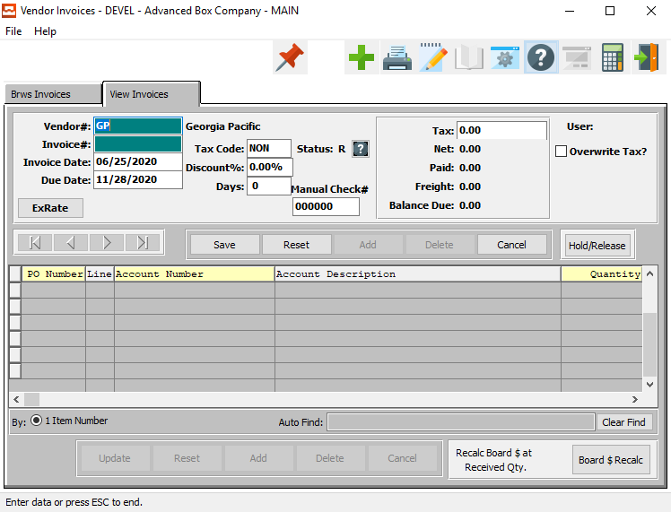

#### SAVE

Click the ***“Save”*** button to save all changes to the current AP Invoice.

#### RESET

Click the ***“Reset”*** button to reset all fields to their original state.

#### CANCEL

Click the ***“Cancel”*** button to cancel all changes to the AP Invoice without saving.

#### HOLD/RELEASE

Click the ***“Hold/Release”*** button to change the status of the currently selected Recurring Invoice from “Released” to “On Hold”.

#### BOARD & RECALC

Click the ***“Board & Recalc”*** button to recalculate any changes made to the current invoice.

### Add/Update Invoice Field Definitions

#### Vendor #

Enter the vendor number and press the enter key to use this vendor. Press the ***“F1”*** function key to search and press ***“Enter”*** on selected vendor, press the ***“Page Up” or “Page Down”*** keys to scroll through vendors or enter the first few letters in the vendor’s name and press ***“Enter”***.

#### Invoice #

This field is only used if a Purchase Order has been entered for this vendor through Purchase Order Processing. The Invoice number has to be unique for this vendor (two vendors can have the same invoice number, but one vendor can't use the same invoice number more than once).

#### Invoice Date

Enter the date of the invoice. This system will default to the current date.

#### Due Date

Enter the date this invoice is to be due. After entering the due date, and upon pressing the ***“Enter”*** key, the line item screen will appear if the invoice already exists. If the number of discount days is entered, the system calculates the due date by adding the number of days to the invoice date.

#### Tax Code

The Tax Codes file allows your company to list a group of tax codes so that taxable items will be multiplied by this tax rate. The reason for multiple tax structures would be for multiple groups such as city, state, and county taxes to be applied to an invoiced item. Another example would be a Canadian tax group such as PST and GST taxes applied to an invoiced item.

#### Discount %

Enter the discount percentage.

#### Days

Enter the number of days for the discount allowance.

#### Status

The current status of the recurring invoice. Valid Options are as follows.

|  |  |
| --- | --- |
| O | On Hold |
| R | Released |

#### Manual Check #

Enter a manual check number to add to this recurring invoice.

#### Tax

Enter a new tax percentage.

#### Overwrite Tax? – Toggle Box

To overwrite the current taxable state of any items on this invoice, make sure that the Overwrite toggle box is checked.

### Add/Update Invoice Line

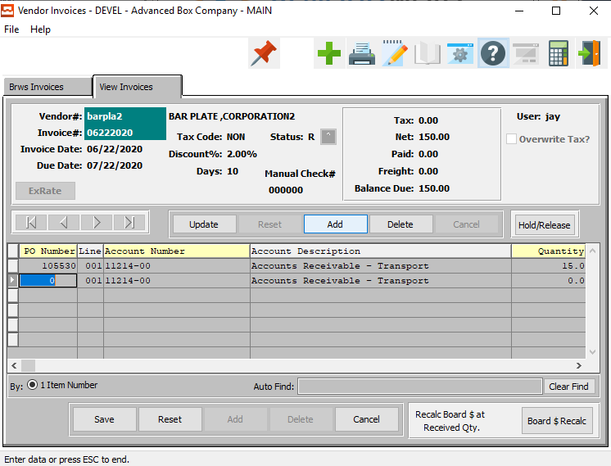

#### SAVE

Click the ***“Save”*** button to save all changes to the current Invoice Line Item.

#### RESET

Click the ***“Reset”*** button to reset all fields to their original state.

#### CANCEL

Click the ***“Cancel”*** button to cancel all changes to the Invoice Line Item without saving.

#### BOARD & RECALC

Click the ***“Board & Recalc”*** button to recalculate any changes made to the current invoice.

### Add/Update Invoice Line Field Definitions

#### PO Number

Enter a valid purchase order number or press ***“F1”*** to lookup. If a purchase order number exists in the PO file, then it must be used or left as zero. If there are multiple receipts towards the PO, then also choose the applicable receipt.

#### Line

The system maintains the line number sequence of the invoice. To access the line items, simply press the ***“Enter”*** key when on the due date field.

#### Account Number

The system will display the default General Ledger account number assigned to this vendor in Vendor File Maintenance. The description will default from the General Ledger Chart of Accounts. If you want to accept the default General Ledger account number, simply press the ***“Enter”*** key.

If you want to change the General Ledger expense number, press the ***“F1”*** function key to search valid account numbers. Alternatively, you may enter the General Ledger number then press ***“Enter”***, or press the ***“Page Up” or “Page Down”*** keys to scroll through the G/L Accounts File.

In order to distribute this expense over several accounts, the system allows the use of as many lines as necessary. You apply the proper portion to each G/L expense account. Press the ***“F4”*** function key to stop entering the line items and then press the ***“F”*** (Finish) key to finish this transaction, after the entering the entire invoice.

#### Account Description

Enter a brief description of this line item relative to the G/L account number.

#### Quantity

Enter the quantity ordered for this item.

#### UOM (Quantity)

The sell price unit of measure defaults to M for per thousand, however this may be modified. Each unit of measure will yield a different total selling price.

Valid Units of Measure are:

|  |  |
| --- | --- |
| C | Per Hundred |
| CS | Per Case |
| EA | Per Each |
| L | Per Lot |
| M | Per Thousand |

#### Price

Enter the unit price for this item.

#### UOM (Price)

The sell price unit of measure defaults to M for per thousand, however this may be modified. Each unit of measure will yield a different total selling price.

Valid Units of Measure are:

|  |  |
| --- | --- |
| C | Per Hundred |
| CS | Per Case |
| EA | Per Each |
| L | Per Lot |
| M | Per Thousand |

#### Tax

If this item is taxable, enter a ***“Y”*** in this field. If this item is not taxable, enter an ***“N”*** in this field.

#### Square Feet

Enter square feet per sheet if used or press enter to leave field as zeros.

#### Amount

The system calculates the invoice amount by adding all of the total line item dollar amounts.

#### Item Description

Enter a brief description of this line item. If using a Purchase order to bring in the line item, then this will automatically default from the purchase order and display the item description.

## Enter/Edit Recurring AP Invoices [VU2]

### Browse Invoices

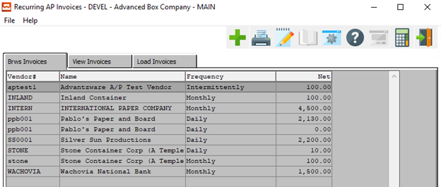

#### ADD

Click the ***“Green + Icon”*** to add a new Recurring AP Invoice.

### View Invoice

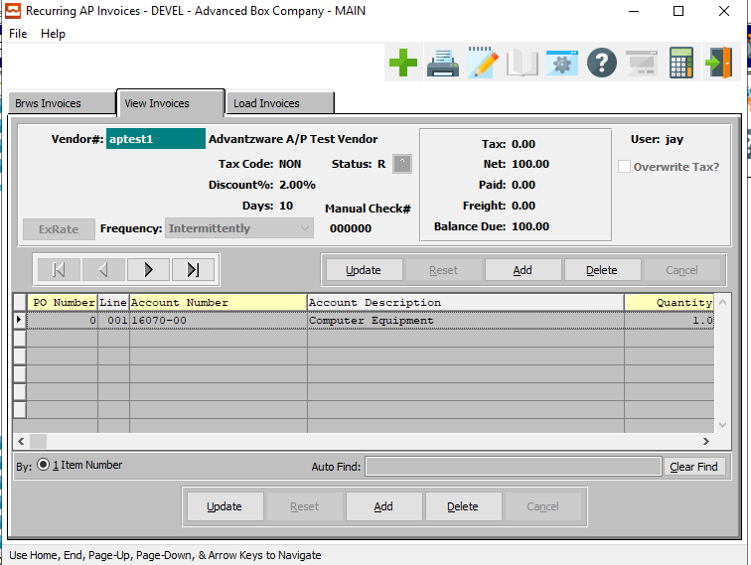

#### UPDATE

To change the currently selected Recurring Invoice, simply click the ***“Update***” button in the middle of the screen.

#### ADD

To add a new Recurring Invoice, simply click the ***“Green + Icon”*** button at the top of the Recurring AP Invoices screen.

Alternatively, click the ***“Add”*** button in the middle of the screen.

#### DELETE

To delete the currently selected Recurring Invoice, simply press the ***"D"*** key. Alternatively, click the ***“Delete”*** button at the bottom of the screen.

#### NEXT

Press ***"N"*** (Next) to find next Recurring Invoice to view or modify. Alternatively, press the ***“Right Arrow”*** on the screen.

#### PREVIOUS

Press ***"P"*** (Previous) to find previous Recurring Invoice to view or modify. Alternatively, press the ***“Left Arrow”*** on the screen.

#### UPDATE (Line)

To change the currently selected Invoice Line, simply click the ***“Update***” button at the bottom of the screen.

#### ADD (Line)

Click the ***“Add”*** button at the bottom of the screen to add a new Recurring Invoice Line.

#### DELETE (Line)

To delete the currently selected Recurring Inoice Line, simply press the ***"D"*** key. Alternatively, click the ***“Delete”*** button at the bottom of the screen.

### Add/Update Invoice

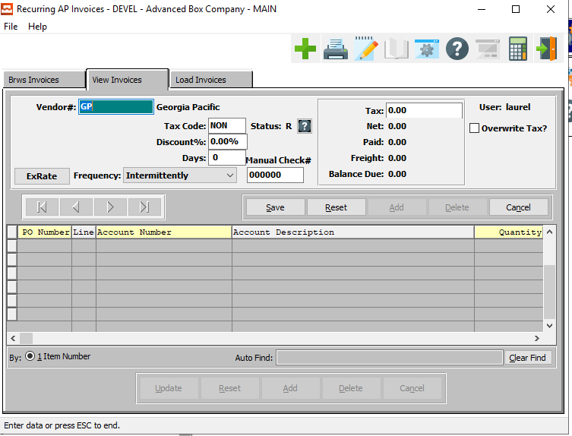

#### SAVE

Click the ***“Save”*** button to save all changes to the current Recurring Invoice.

#### RESET

Click the ***“Reset”*** button to reset all fields to their original state.

#### CANCEL

Click the ***“Cancel”*** button to cancel all changes to the Recurring Invoice without saving.

### Add/Update Invoice Field Definitions

#### Vendor #

Enter the vendor number and press the enter key to use this vendor. Press the ***“F1”*** function key to search and press ***“Enter”*** on selected vendor, press the ***“Page Up” or “Page Down”*** keys to scroll through vendors or enter the first few letters in the vendor’s name and press ***“Enter”***.

#### Tax Code

The Tax Codes file allows your company to list a group of tax codes so that taxable items will be multiplied by this tax rate. The reason for multiple tax structures would be for multiple groups such as city, state, and county taxes to be applied to an invoiced item. Another example would be a Canadian tax group such as PST and GST taxes applied to an invoiced item.

#### Discount %

Enter the discount percentage.

#### Days

Enter the number of days for the discount allowance.

#### Status

The current status of the recurring invoice. Valid Options are as follows.

|  |  |
| --- | --- |
| O | On Hold |
| R | Released |

#### Manual Check #

Enter a manual check number to add to this recurring invoice.

#### Tax

Enter a new tax percentage.

#### Overwrite Tax? – Toggle Box

To overwrite the current taxable state of any items on this invoice, make sure that the Overwrite toggle box is checked.

### Add/Update Invoice Line

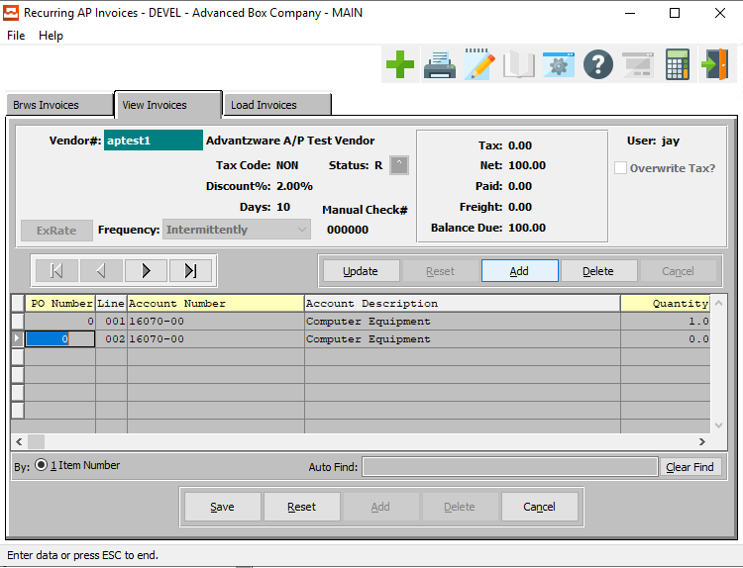

#### UPDATE

To change the main information of currently selected Recurring Invoice, simply click the ***“Update***” button at the bottom of the screen.

#### ADD

To add a new Recurring Invoice, simply click the ***“Green + Icon”*** button at the top of the Recurring AP Invoices screen.

Alternatively, click the ***“Add”*** button in the middle of the screen.

#### DELETE

To delete the entire currently selected Recurring Invoice, simply press the ***"D"*** key. Alternatively, click the ***“Delete”*** button in the middle of the screen.

#### NEXT

Press ***"N"*** (Next) to find next Recurring Invoice to view or modify. Alternatively, press the ***“Right Arrow”*** on the screen.

#### PREVIOUS

Press ***"P"*** (Previous) to find previous Recurring Invoice to view or modify. Alternatively, press the ***“Left Arrow”*** on the screen.

#### SAVE

Click the ***“Save”*** button to save all changes to the current Invoice Line.

#### RESET

Click the ***“Reset”*** button to reset all fields to their original state.

#### CANCEL

Click the ***“Cancel”*** button to cancel all changes to the Invoice Line without saving.

### Add/Update Invoice Line Field Definitions

#### PO Number

Enter a valid purchase order number or press ***“F1”*** to lookup. If a purchase order number exists in the PO file, then it must be used or left as zero. If there are multiple receipts towards the PO, then also choose the applicable receipt.

#### Line

The system maintains the line number sequence of the invoice. To access the line items, simply press the ***“Enter”*** key when on the due date field.

#### Account Number

The system will display the default General Ledger account number assigned to this vendor in Vendor File Maintenance. The description will default from the General Ledger Chart of Accounts. If you want to accept the default General Ledger account number, simply press the ***“Enter”*** key.

If you want to change the General Ledger expense number, press the ***“F1”*** function key to search valid account numbers. Alternatively, you may enter the General Ledger number then press ***“Enter”***, or press the ***“Page Up” or “Page Down”*** keys to scroll through the G/L Accounts File.

#### Account Description

Enter a brief description of this line item relative to the G/L account number.

#### Quantity

Enter the quantity ordered for this item.

#### UOM

The sell price unit of measure defaults to M for per thousand, however this may be modified. Each unit of measure will yield a different total selling price.

Valid Units of Measure are:

|  |  |
| --- | --- |
| C | Per Hundred |
| CS | Per Case |
| EA | Per Each |
| L | Per Lot |
| M | Per Thousand |

#### Tax

If this item is taxable, enter a ***“Y”*** in this field. If this item is not taxable, enter an ***“N”*** in this field.

#### Square Feet

Enter square feet per sheet if used or press enter to leave field as zeros.

#### Amount

The system calculates the invoice amount by adding all of the total line item dollar amounts.

#### Item Description

Enter a brief description of this line item. If using a Purchase order to bring in the line item, then this will automatically default from the purchase order and display the item description.

### Load Invoices

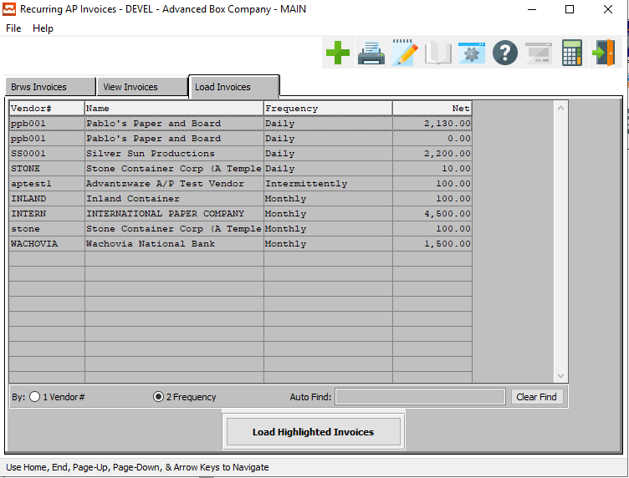

#### LOAD HIGHLIGHTED INVOICES

Clicking the ***“Load Highlighted Invoices”*** button will select all highlighted recurring Accounts Payable invoice entries.

To choose multiple invoices, press the ***“Control”*** key and click any desired lines.

## AP Invoice Posting [VU3]

### Selection Parameters

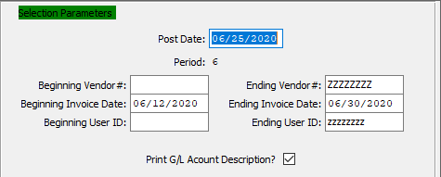

#### Post Date

Enter the date that you want these transactions posted to.

#### Period

This is the period number of the transaction date relative to the fiscal year.

#### Beginning Vendor # / Ending Vendor #

Enter the beginning and ending Vendor Number to post invoices for.

#### Beginning Invoice Date / Ending Invoice Date

Enter the beginning and ending Invoice Date to post invoices for.

#### Beginning User ID / Ending User ID

Enter the beginning and ending User ID to post invoices for.

#### Print G/L Account Description? – Toggle Box

To print the General Ledger account description on the report, make sure that this toggle box is checked.

### Output Destination

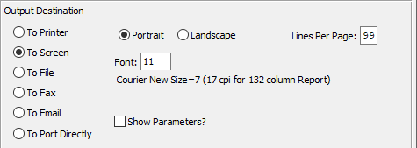

#### Destination Choice

To choose the destination where the document should be printed, please make sure that desired output destination choice bubble is toggled.

#### Layout Choice

To choose the preferred layout of Landscape vs. Portrait, please make sure the desired option choice bubbled is toggled.

#### Lines Per Page

Lines per page on the report when printing.

#### Font

Enter the font number to use with this report (Font 11 is default).

#### Show Parameters? – Toggle Box

To show parameters, make sure that the toggle box is ‘ticked’ with a checkmark.

# **Write AP Credit/Debit Memos [VW]**

## Overview

This menu gives the options of Adding and Editing Debit and Credit Memos, and printing a Debit/Credit Register. The first screen is used to add new Debit or Credit Memos onto the system. Once all are added, you will print a Register to check for any possible mistakes. If you find any mistakes, the Debit/Credit Memos can be edited from the first screen before posting.

Once all errors are corrected and you are satisfied with the Memos, you will Post the Memos which is prompted for in the Register screen. If you choose ***“Y”*** (Yes) to Post, the Memos will be updated in the vendor files along with the general ledger files. If you choose ***“N”*** (No) to Post, the Memos will not be updated at that time.

## Add/Edit DB/CR Memos [VW1]

Use Debit and Credit Memos to adjust Accounts Payable Invoice balances. A Vendor submits, for example, an invoice (one already entered into and posted by the system), and the company returned the merchandise, issue a memo to adjust (zero out) this invoice. In an incorrectly entered (and posted) invoice, issue a memo to adjust the balance due.

Use the ***“Page Up” or “Page Down”*** keys to scroll through the vendor file, and press ***“Enter”*** on selected item.

### Browse Memos

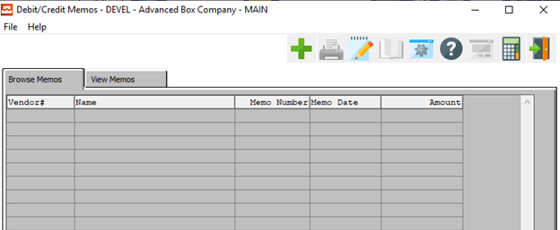

#### ADD

Click the ***“Green + Icon”*** to add a new Debit/Credit Memo.

### View Memo

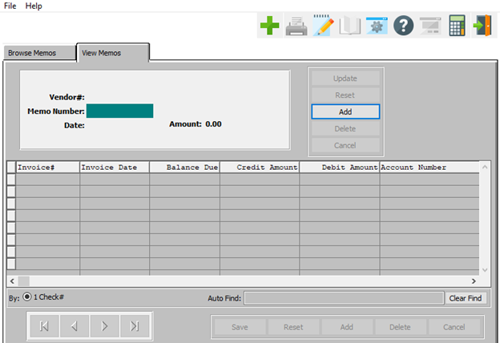

#### ADD

To add a new Debit/Credit Memo, simply click the ***“Green + Icon”*** button at the top of the Memo screen.

Alternatively, click the ***“Add”*** button at the top of the screen.

### Add/Update Memo

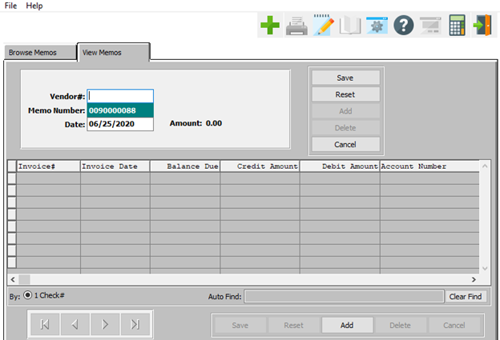

#### SAVE

Click the ***“Save”*** button to save all changes to the current Memo.

#### RESET

Click the ***“Reset”*** button to reset all fields to their original state.

#### CANCEL

Click the ***“Cancel”*** button to cancel all changes to the Memo without saving.

#### ADD

Click the ***“Add”*** button at the bottom of the screen to add a new Memo Line.

### Add/Update Memo Field Definitions

#### Vendor #

Enter the vendor number, Press the ***“F1”*** function key to search, enter the first few letters in the vendor’s name or Press the ***“Page Up” or “Page Down”*** keys to scroll through vendor file. Press the ***“Enter”*** key to select vendor highlighted on screen.

#### Memo Number

The system defaults to the next available number.

#### Date

Enter the date of the debit or credit memo. The system defaults to the current system date.

### Add/Update Memo Line

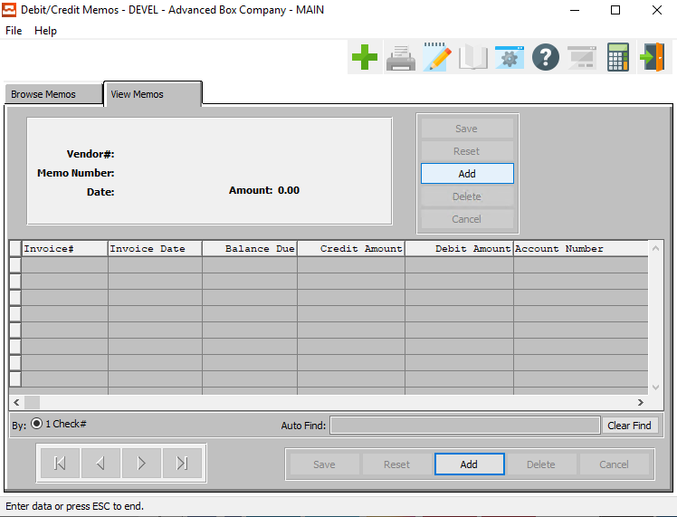

#### ADD

To add a new Memo, simply click the ***“Green + Icon”*** button at the top of the Memo screen.

Alternatively, click the ***“Add”*** button at the top of the screen.

#### ADD (Line)

Click the ***“Add”*** button at the bottom of the screen to add a new Memo Line.

### Add/Update Memo Line Field Definitions

#### Invoice #

Enter the invoice number that the debit or credit memo applies to. Press the ***“F1”*** function key to search, or press the ***“Page Up” or “Page Down”*** keys to scroll through invoices, and then press ***“Enter”*** on selected item.

#### Invoice Date

The system displays the due date of the invoice.

#### Balance Due

The system displays the remaining balance due on that invoice.

#### Credit Amount

Enter the amount of the credit memo to this account number of the invoice.

#### Debit Amount

Enter the amount of the debit memo to this account number of the invoice.

#### Account Number

You will need to enter the G/L account number to apply the amount to, or press the ***“Page Up” or “Page Down”*** keys to scroll through the G/L accounts file, and then press ***“Enter”*** to accept the account number. The Account number defaults to the G/L account number in the vendor's file.

#### Account Description

Enter a short description for the account.

## Debit/Credit Register [VW2]

This is a report that lists all the unposted memos entered before posting them to the vendor and General Ledger files. This report must be run before posting can occur. After the report has finished printing you will then be asked if you want to then post to AP/GL files. Enter yes if the register information is correct. If you enter no, you must reprint the register in order to post.

### Selection Parameters

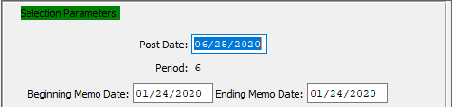

#### Post Date

Enter the date that you want these transactions posted to. Post a Memo, for example, with a Memo date of 12/31/92 in either December 1992 or January 1993, depending upon circumstances.

#### Period

This is the period number of the transaction date relative to the fiscal year.

#### Beginning Memo Date / Ending Memo Date

Enter the beginning and ending Memo Date to run the report for.

### Output Destination

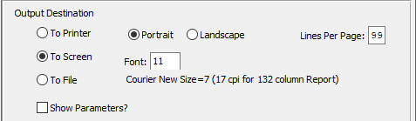

#### Destination Choice

To choose the destination where the document should be printed, please make sure that desired output destination choice bubble is toggled.

#### Layout Choice

To choose the preferred layout of Landscape vs. Portrait, please make sure the desired option choice bubbled is toggled.

#### Lines Per Page

Lines per page on the report when printing.

#### Font

Enter the font number to use with this report (Font 11 is default).

#### Show Parameters? – Toggle Box

To show parameters, make sure that the toggle box is ‘ticked’ with a checkmark.

# **Build Payment Selection List [VB]**

## Overview

This menu gives you three options for payment. Selection by Due Date, Vendor, and a Selection Register. For the Selection by Due Date the system selects all invoices in the Open Payables file with a due date equal to the ‘desired due date’ plus the ‘and next’ number of days, or any earlier date, for payment.

Please Note: This function should only be used if printing checks through the Check Processing, A/P Check option (K-4-1). If you are paying checks through Cash Disbursements or manual checks, do not use the Payment selection options.

For Selection by Vendor, this option allows you to select specific vendor invoices for immediate payment.

The Selection Register report lists all invoices selected for payment. This will provide you with a total of the invoices selected, payments to be made, and discounts taken, so that you can verify the amount of cash necessary to pay these invoices.

## Select by Due Date [VB1]

### Overview

The system selects all invoices in the Open Payables file with a due date equal to the 'desired due date' plus the 'and next' number of days, or any earlier date, for payment.

Please Note: This function should only be used if printing checks through the Check Processing, A/P Check option (K-4-1). If you are paying checks through Cash Disbursements or manual checks, do not use the Payment selection options.

### Select by Due Date Screen

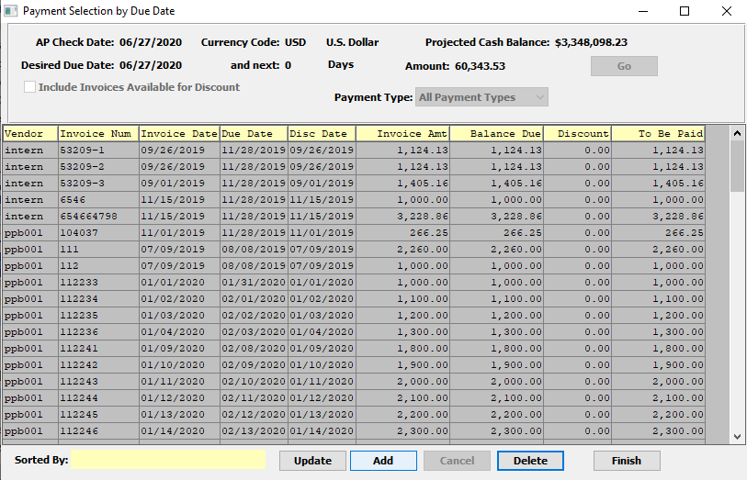

#### UPDATE

To change the currently selected Payment, simply click the ***“Update***” button at the bottom of the screen.

#### ADD

Click the ***“Add”*** button at the bottom of the screen to add a new Payment.

#### DELETE

To delete the currently selected payment, simply press the ***"D"*** key. Alternatively, click the ***“Delete”*** button at the bottom of the screen.

#### FINISH

Click the ***“Finish”*** button to close the Payment Selection screen.

### Select by Due Date Field Definitions

#### AP Check Date

Enter the date of the check.

#### Desired Due Date

Enter the due date, that the system will use, for payment selection criteria. The system selects all invoices, in the Open Payable file, with a due date equal to or less than the desired due date plus the "AND NEXT" number of days.

#### And Next: Number of Days

Enter the number of days after the desired due date for payment selection.

### Add/Update Due Date

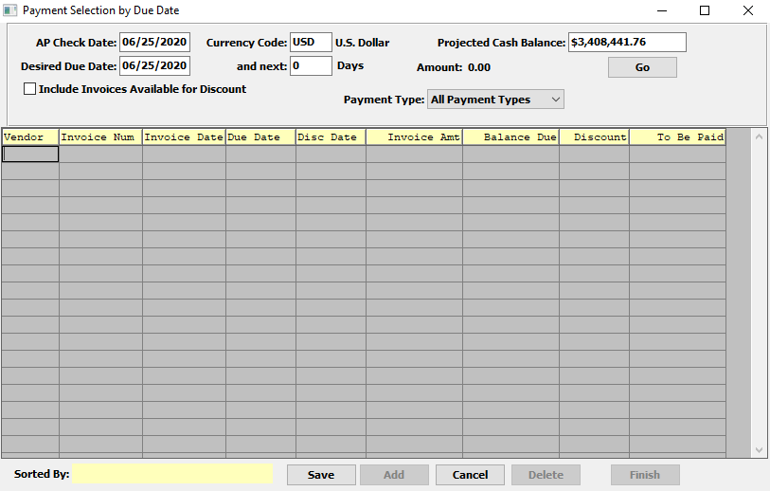

#### SAVE

Click the ***“Save”*** button to save all changes to the current Payment Selection.

#### CANCEL

Click the ***“Cancel”*** button to cancel all changes to the Payment Selection without saving.

### Add/Update Due Date Field Definitions

#### Vendor

Enter the vendor number and press the enter key to use this vendor. Press the ***“F1”*** function key to search and press ***“Enter”*** on selected vendor, press the ***“Page Up” or “Page Down”*** keys to scroll through vendors or enter the first few letters in the vendor’s name and press ***“Enter”***.

#### Invoice

Enter the invoice number of the invoice.

#### Invoice Number

Enter a valid invoice number for the payment. Alternatively, press the ***“F1”*** button to look up invoices.

#### Invoice Date

Enter the original date of the invoice.

#### Due Date

Enter the due date for the payment.

#### Discount Date

Enter the original date of the discount.

#### Invoice Amount

Enter the total amount form the invoice.

#### Balance Due

The system calculates the net invoice balance by subtracting the amounts paid from the net invoice amount. The Debit and Credit Memos further adjust this amount.

#### Discount

Enter the total amount to apply to the discount taken on the specified vendor invoice. Press the ***“Enter”*** key again and then the Total Amount field updates at the top.

#### To Be Paid

Enter the total amount to pay to the vendor on the specified invoice. Press the ***“Enter”*** key and you can then enter a discount amount.

## Select by Vendor [VB2]

This option allows you to select specific vendor invoices for immediate payment.

Please Note: This function should only be used if printing checks through the Check Processing, A/P Check option (K-4-1). If you are paying checks through Cash Disbursements or manual checks, do not use the Payment selection options.

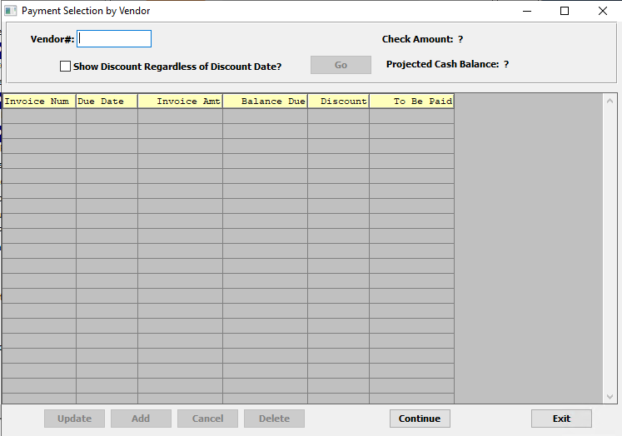

#### Vendor #

Enter actual vendor number, press the ***“F1”*** function key to search, or press the ***“Page Up” or “Page Down”*** keys to scroll through vendors, and then press the ***“Enter”*** key on the selected vendor.

#### Show Discount Regardless of Discount Date? – Toggle Box

To show any discount applied to the invoice, even if the discount expiration date has passed, make sure that this toggle box is checked.

## Selection Register [VB3]

This report lists all invoices selected for payment. This will provide you with a total of the invoices selected, payments to be made, and discounts taken, so that you can verify the amount of cash necessary to pay these invoices.

### Selection Parameters

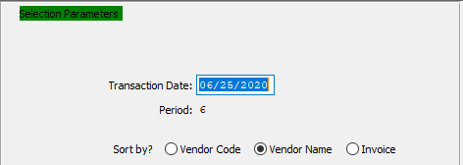

#### Transaction Date

Enter the date that you want these transactions posted to. Post a Memo, for example, with a Memo date of 12/31/92 in either December 1992 or January 1993, depending upon circumstance. You will then be prompted as to whether the date you entered is correct.

#### Period

This is the period number of the transaction date relative to the fiscal year. This field cannot be modified.

#### Sort By? (Choice)

To choose the preferred Sorting Method of Vendor Code vs. Vendor Name vs. Invoice Number, please make sure the desired option choice bubble is toggled.

### Output Destination

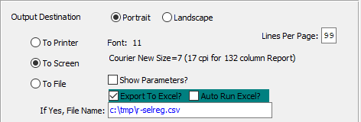

#### Destination Choice

To choose the destination where the document should be printed, please make sure that desired output destination choice bubble is toggled.

#### Layout Choice

To choose the preferred layout of Landscape vs. Portrait, please make sure the desired option choice bubbled is toggled.

#### Lines Per Page

Lines per page on the report when printing.

#### Font

Enter the font number to use with this report (Font 11 is default).

#### Show Parameters? – Toggle Box

To show parameters, make sure that the toggle box is ‘ticked’ with a checkmark.

#### Export to Excel? – Toggle Box

To export the printed file to an excel document, make sure that the Export to Excel toggle box is checked.

#### Auto Run Excel? – Toggle Box

To automatically open the new excel document, make sure that the Auto Run Excel toggle box is checked.

#### If Yes, File Name

If exporting the file to Excel, enter the desired file name.

# **Check Processing [VC]**

## Overview

This Menu gives you options for printing checks. The first option will have the computer print the checks. You will be asked for the pertinent information and then it will be printed. If you have to write a check by hand, the Manual Checks screen will be used. It will ask for the information for that particular check.

The Check Register will list all of the checks, printed or manually written, listed by check numbers and will give grand totals. The Void A/P Checks option is used to void an Accounts Payable check after it has already been posted. The General Ledger entries will be reversed, and the invoice will once again become open.

## Print AP Checks [VC1]

Use this option after using the payment selection steps to perform the actual check printing. The task of aligning your checks is entirely printer dependent.

### Selection Parameters

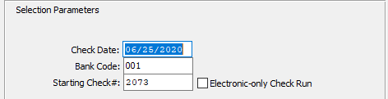

#### Check Date

Enter the date to print on the actual checks.

#### Bank Code

Enter the bank code that applies to this check run, press the “***F1”*** function key to search, or press the ***“Page Up” or “Page Down”*** keys to scroll through the bank file, and then press the ***“Enter”*** key to accept the Bank.

#### Starting Check #

Enter the starting check number to print on the checks whether printing selected checks for the first time or reprinting already printed checks.

#### Electronic-Only Check Run – Toggle Box

To print only the electronic checks from the Starting check Number, make sure that the Electronic-Only Check Run toggle box is checked.

### Reprint Options

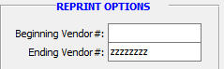

#### Beginning Vendor # / Ending Vendor #

Use this option to reprint any checks. For example, the checks jammed in the printer or were misaligned. Enter the starting and ending vendor numbers. Press ***“Enter”*** and leave field blank if you are not reprinting checks.

### Output Destination

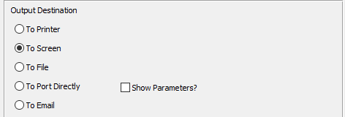

#### Destination Choice

To choose the destination where the document should be printed, please make sure that desired output destination choice bubble is toggled.

#### Show Parameters? – Toggle Box

To show parameters, make sure that the toggle box is ‘ticked’ with a checkmark.

## Manual Checks [VC2]

Occasionally you must write a check by hand. You must use this function to record these checks. This option allows you to enter into the system the check amount, the vendor, and the invoice numbers being paid with this manual check. The checks entered through this function will display on the next printing of the Accounts Payable Check Register, if the manual option is selected.

### Browse Checks

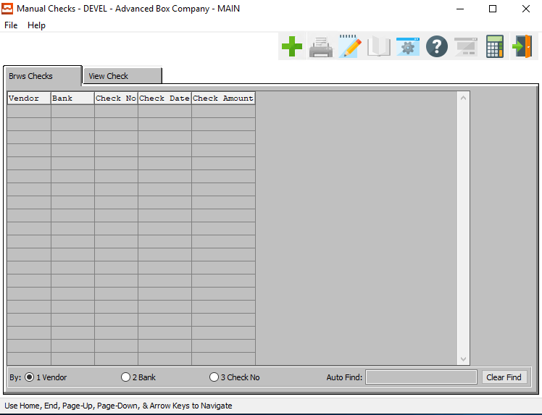

#### ADD

Click the ***“Green + Icon”*** to add a new Manual Check.

### View Checks

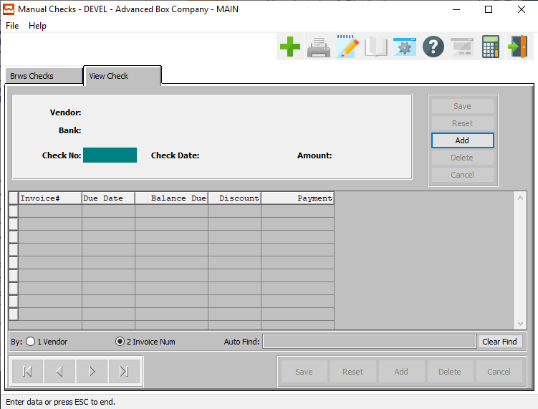

#### ADD

To add a new XXX, simply click the ***“Green + Icon”*** button at the top of the Manual Checks screen.

Alternatively, click the ***“Add”*** button at the top of the screen.

### Add/Update Check

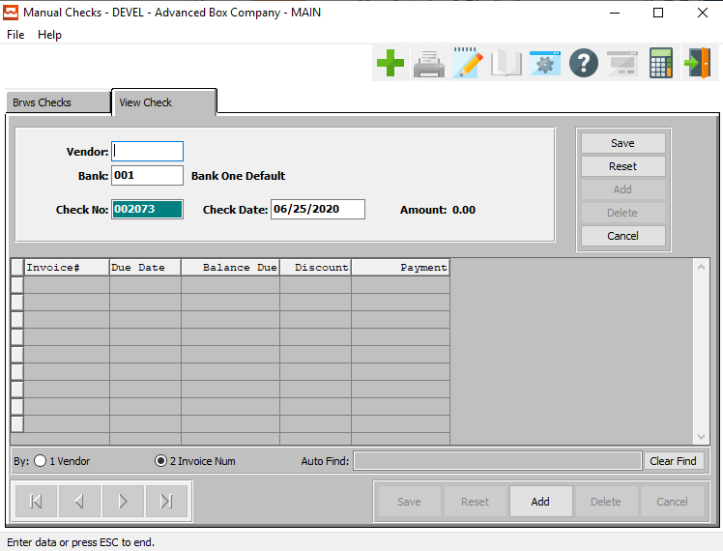

#### SAVE

Click the ***“Save”*** button to save all changes to the current Check.

#### RESET

Click the ***“Reset”*** button to reset all fields to their original state.

#### CANCEL

Click the ***“Cancel”*** button to cancel all changes to the Check without saving.

#### ADD

Click the ***“Add”*** button at the bottom of the screen to add a new invoice line.

### Add/Update Check Field Definitions

#### Vendor

Enter a valid vendor account number, press the ***“F1”*** function to search for a vendor, or press the ***“Page Up” or “Page Down”*** keys to scroll through the vendor file. When the correct vendor displays on the screen, press the ***“Enter”*** key to accept the vendor.

#### Bank

Enter the bank code relative to the bank account of the check, press the ***“F1”*** function key to search for a bank, or press the ***“Page Up” or “Page Down”*** keys to scroll through the bank file. When the correct bank displays on the screen, press the ***“Enter”*** key to accept the bank.

#### Check Number

Enter the check number of the check paid.

#### Check Date

Enter the check date. This will default to the system date.

### Add/Update Check Line Field Definitions

#### Invoice #

Enter the invoice number, press ***“F1”*** function key to search for the correct vendor invoice, or press the ***“Page Up” or “Page Down”*** keys to scroll through the invoice file. Then press the ***“Enter”*** key when the selected invoice displays.

Enter the amount to pay against this invoice, and press the ***“Enter”*** key to accept. Enter the amount of the discount taken against the invoice and press the ***“Enter”*** key to accept. Press the ***“Enter”*** key again to return to invoice number field to select another invoice or press the ***“F”*** (Finish) key to end the transaction and enter another manual check or press ***“Q”*** (Quit) to exit out of the screen.

#### Due Date

Enter the due date for the invoice payment.

#### Balance Due

Enter the balance remaining for the current invoice before this check payment.

#### Discount

Enter the amount of the discount taken against the invoice and press the ***“Enter”*** key to accept. Press the ***“Enter”*** key again to return to invoice number field to select another invoice or press the ***“Escape”*** key 3 times to return to the menu.

#### Payment

Enter the amount to pay against this invoice, and press the ***“Enter”*** key to accept.

Please Note: In order to post checks, you need to run the check register.

## Check Register [VC3]

After all of the checks have printed (or manual checks entered), you must print the check register. This is a summary of all the checks printed in this batch. This report lists the checks in numerical order, with the vendor numbers, vendor names, invoice numbers and invoice amounts. It also includes totals for each check and the grand total of all checks written.

### Selection Parameters

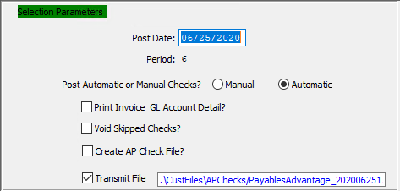

#### Post Date

Enter the date that you want these transactions posted to.

#### Period

This is the period number of the transaction date relative to the fiscal year.

#### Post Automatic or Manual Checks? (Choice)

At this time, the user must tell the system whether you are posting manually entered checks or posting automatically printed checks (or automatic). This function allows the user to enter as many manual or automatic checks throughout a period of time without having to post after every batch. It also keeps the two types separate so that when the user decides to post one type of check, it will not post the other type.

#### Print Invoice GL Account Detail? – Toggle Box

To print an invoice’s General Ledger account detail on the report, make sure that this toggle box is checked.

#### Void Skipped Checks? – Toggle Box

To automatically void and skipped checks, make sure that the Void Skipped Checks toggle box is checked.

#### Crate AP Check File? – Toggle Box

To create an Accounts Payable check file, make sure that the Create AP Check File toggle box is checked.

#### Transmit File – Toggle Box

To transmit the created report to a file, make sure that the Transmit File toggle box is checked.

### Output Destination

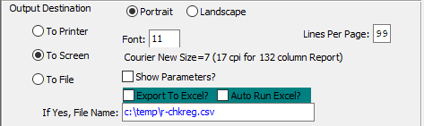

#### Destination Choice

To choose the destination where the document should be printed, please make sure that desired output destination choice bubble is toggled.

#### Layout Choice

To choose the preferred layout of Landscape vs. Portrait, please make sure the desired option choice bubbled is toggled.

#### Lines Per Page

Lines per page on the report when printing.

#### Font

Enter the font number to use with this report (Font 11 is default).

#### Show Parameters? – Toggle Box

To show parameters, make sure that the toggle box is ‘ticked’ with a checkmark.

#### Export to Excel? – Toggle Box

To export the printed file to an excel document, make sure that the Export to Excel toggle box is checked.

#### Auto Run Excel? – Toggle Box

To automatically open the new excel document, make sure that the Auto Run Excel toggle box is checked.

#### If Yes, File Name

If exporting the file to Excel, enter the desired file name.

## Void AP Checks [VC4]

This Program is used to void an Accounts Payable check after it has already been posted. The general ledger entries will be reversed, and the invoice will once again become open.

### Browse Checks

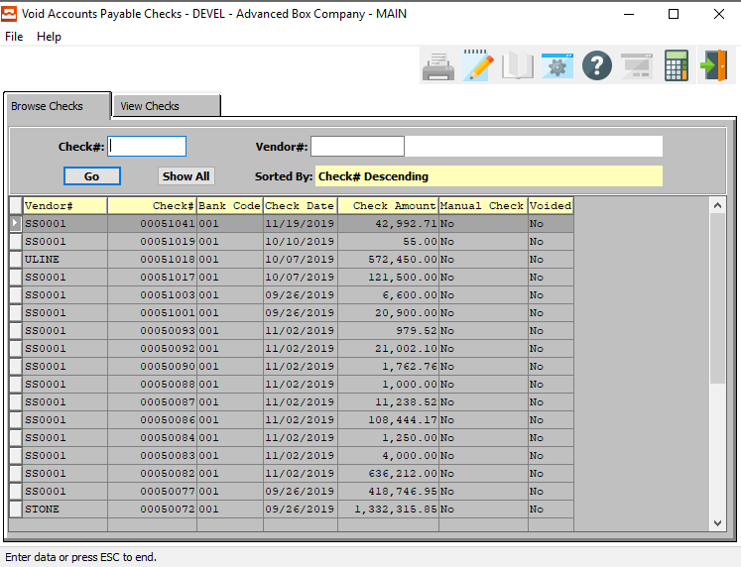

#### Check #

Enter a check number to search for.

#### Vendor #

Enter the vender number for this invoice. When looking-up a vendor press the ***“F1”*** key and you will get a look-up screen of all vendors available.

#### Vendor Name

The Vendor name will automatically transfer from the Vendor File as soon as the user enters or chooses a valid vendor number.

### View Check

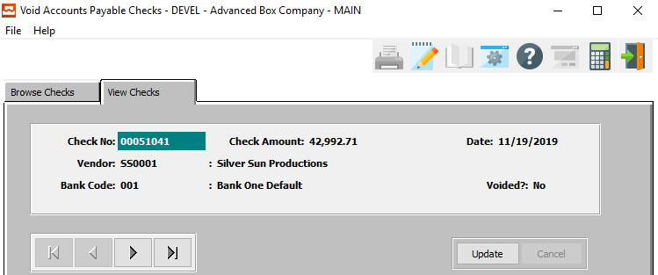

#### UPDATE

To change the currently selected check, simply click the ***“Update***” button at the bottom of the screen.

#### NEXT

Press ***"N"*** (Next) to find next check to view or modify. Alternatively, press the ***“Right Arrow”*** on the screen.

#### PREVIOUS

Press ***"P"*** (Previous) to find previous check to view or modify. Alternatively, press the ***“Left Arrow”*** on the screen.

### Update Check

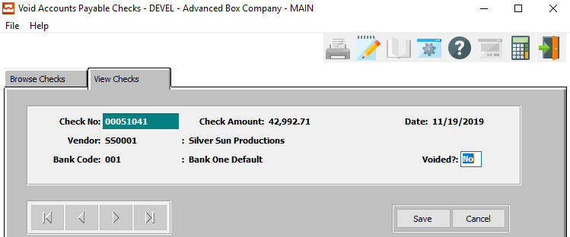

#### SAVE

Click the ***“Save”*** button to save all changes to the current check.

#### CANCEL

Click the ***“Cancel”*** button to cancel all changes to the check without saving.

#### Check Number

Enter the check number to be voided either by using the ***“F”*** (Find) key and then entering the check number or by using the ***“N”*** (Next) or ***“P”*** (Previous) keys.

#### Voided? – Toggle Box

To mark the current check as voided, make sure that the Voided toggle box is checked.

## Voided Check Register [VC5]

### Selection Parameters

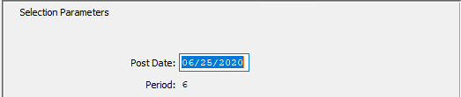

#### Post Date

Enter the date you want these transactions posted to. To post a check, for example, with a check date of 12/31/92 in either December 1992 or January 1993 depending upon circumstances.

#### Period

This is the period # of the transaction date relative to the fiscal year.

### Output Destination

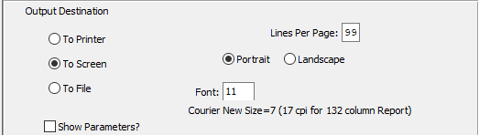

#### Destination Choice

To choose the destination where the document should be printed, please make sure that desired output destination choice bubble is toggled.

#### Layout Choice

To choose the preferred layout of Landscape vs. Portrait, please make sure the desired option choice bubbled is toggled.

#### Lines Per Page

Lines per page on the report when printing.

#### Font

Enter the font number to use with this report (Font 11 is default).

#### Show Parameters? – Toggle Box

To show parameters, make sure that the toggle box is ‘ticked’ with a checkmark.

# **Track Bank Reconciliation [VT]**

## Overview

This menu allows Check Reconciliation, a Reconciliation Register and a Report. The Check Reconciliation option is used to reconcile your Accounts Payable checks when you receive a checking account statement from your bank.

The Reconciliation Register is used to print a report listing any Accounts Payable checks you marked as being reconciled. If the information on the report is correct, you may post the reconciled checks. Once a check is reconciled and posted, no further processing can be done against this check.

The check reconciliation report is used to print a more detailed report. The screen enables you to choose a certain bank account or all bank accounts. It will list just reconciled checks, just un-reconciled checks or both. It also lets you choose a certain range of checks by using the from check number and the to check number fields.

## Bank Reconciliation [VT1]

This program is used to reconcile your Accounts Payable paid checks when you receive a checking account statement from your bank. Use the ***“Next” / ”Previous”*** keys to scroll through checks until the desired check comes up on the screen or press ***“F”*** (Find) key and type in the desired check number.

Press the ***“C”*** (Change) key and change the no to a yes by pressing the ***“Y”*** key. Press ***“Enter”*** to select the check. Repeat these steps until all reconciled checks are selected. Use the ***“Q”*** (Quit) key to exit the screen. The user must now run the reconciliation register.

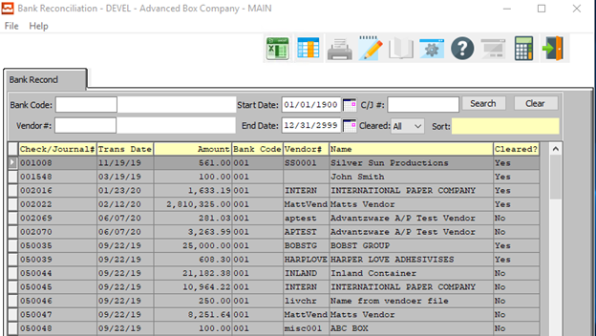

### Bank Reconciliation Field Definitions

#### Bank Code

The Bank the check was drawn from.

#### Bank Name

The Bank the check was drawn from.

#### Vendor #

The vendor the check was paid to.

#### Vendor Name

The vendor the check was paid to.

#### Start Date / End Date

The date the check was written.

#### Check/Journal #

Enter the check number by using ***“F”*** (Find), ***“N”*** (Next), or by ***“P”*** (Previous) and then pressing enter on desired vendor.

#### Cleared (Choice)

This field states whether the check has been reconciled.

## Reconciliation Register [VT2]

The Reconciled Check Register is used to print a report listing any Accounts Payable checks you marked as being reconciled. If the information on the report is correct, you may post the reconciled checks. Once a check is reconciled and posted, no further processing can be done against this check.

### Selection Parameters

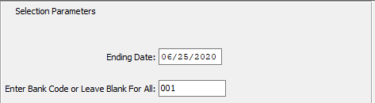

#### Ending Date

Enter an date to end the bank reconciliation.

#### Enter Bank Code or Leave Blank for All

If the user only wishes to reconcile a single bank, enter a valid bank code in this field.

Alternatively, if the user wishes to run the reconciliation for all bank, leave this field blank.

### Output Destination

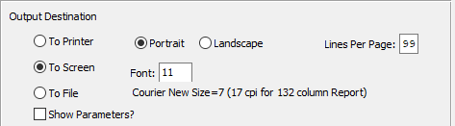

#### Destination Choice

To choose the destination where the document should be printed, please make sure that desired output destination choice bubble is toggled.

#### Layout Choice

To choose the preferred layout of Landscape vs. Portrait, please make sure the desired option choice bubbled is toggled.

#### Lines Per Page

Lines per page on the report when printing.

#### Font

Enter the font number to use with this report (Font 11 is default).

#### Show Parameters? – Toggle Box

To show parameters, make sure that the toggle box is ‘ticked’ with a checkmark.

## Reconciliation Report [VT3]

The check reconciliation report is used to print a more detailed report. The screen enables you to choose a certain bank account or all bank accounts. It will list just reconciled checks, just un-reconciled checks or both. It also lets you choose a certain range of checks by using the from check number and the to check number fields.

### Selection Parameters

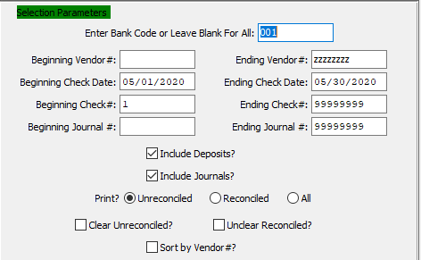

#### Enter Bank Code or Leave Blank for All

Enter the specific bank code or leave blank to select all bank codes.

#### Beginning Vendor # / Ending Vendor #

Enter the beginning and ending Vendor Number to run the reconciliation for.

#### Beginning Check Date / Ending Check Date

Enter beginning and ending date for check search or for range of checks to be cleared.

#### Beginning Check # / Ending Check #

Enter the beginning and ending check number for search or for clearing checks.

#### Beginning Journal # / Ending Journal #

Enter the beginning and ending Journal Number to run the reconciliation for.

#### Include Deposits? – Toggle Box

To include deposits in the reconciliation, make sure that the Include Deposits toggle box is checked.

#### Include Journals? – Toggle Box

To include journal entries in the reconciliation, make sure that the Include Journals toggle box is checked.

#### Print? (Choice)

To choose the preferred Check Option to print of Unreconciled vs. Reconciled (Or All), please make sure the desired option choice bubble is toggled.

#### Clear Unreconciled? – Toggle Box

This feature is used if you want to clear a batch of checks in a row instead of clearing one by one under the check reconciliation menu item.

#### Unclear Reconciled? – Toggle Box

This feature is used if you want to unclear a batch of checks in a row instead of unclearing one by one under the check reconciliation menu item.

#### Sort by Vendor Number? – Toggle Box

To sort the reconciliation report by vendor number, make sure that the Sort by Vendor Number toggle box is checked.

### Output Destination

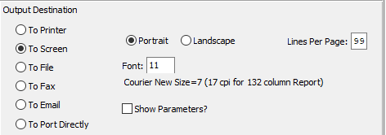

#### Destination Choice

To choose the destination where the document should be printed, please make sure that desired output destination choice bubble is toggled.

#### Layout Choice

To choose the preferred layout of Landscape vs. Portrait, please make sure the desired option choice bubbled is toggled.

#### Lines Per Page

Lines per page on the report when printing.

#### Font

Enter the font number to use with this report (Font 11 is default).

#### Show Parameters? – Toggle Box

To show parameters, make sure that the toggle box is ‘ticked’ with a checkmark.

## Load Reconciliation File [VT4]

### Selection Parameters

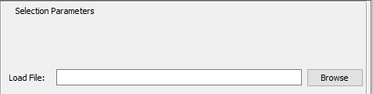

#### Load File

Enter a valid file path to load a reconciliation file. Alternatively, press the ***“F1”*** key to search for a valid file path using the Windows Explorer window.

# **List Cash Disbursements [VL]**

This menu gives the options of Entering and Editing Disbursements, and Printing a Register. The first screen is used to enter Disbursements. Once all are entered, you can print a Register to check for any errors. If any errors occur, you can Edit the Disbursements from the first screen as well.

After all corrections have been made, you will be asked to Post from the Disbursement Register screen. If you choose ***“Y”*** (Yes) to Post, the entries and the general ledger will be updated. If you choose ***“N”*** (No) to Post, the corrections will not be made.

## Enter/Edit Disbursements [VL1]

### Overview

The purpose of this function is to record payments that are not normal Accounts Payable items, such as Tax Payments, payments for minor items such as snow removal. Payments for un-invoiced transactions also use Cash Disbursements. You can use a vendor in the vendor file, but there is no open item in the payable fileor press ***“Enter”*** on vendor # and you can enter a miscellaneous vendor name in the space provided.

In the first part of the Disbursement Entry screen below, you must enter the payee (vendor number), bank where the disbursement is being withdrawn from, check date, check amount and check number. The system will provide today’s date as the default date. The system will automatically credit the general ledger account number set up in the selected bank control file.

Upon completion of the top section, the bottom section will appear so that you can specify the debit portion of the General Ledger distribution. This account number will default from the vendor file maintenance if a vendor # is used, but can be overridden. This states how much to distribute to each G/L account. You can distribute the check to multiple G/L accounts as necessary. The amount on the top section of the screen keeps track of how much is being distributed.

### Browse Disbursements

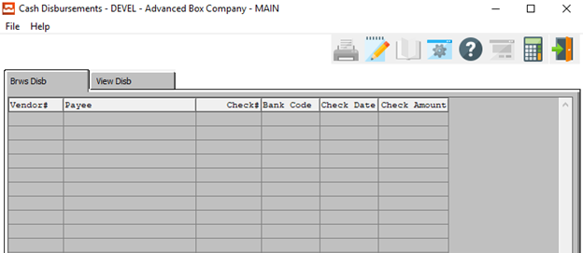

### View Disbursement

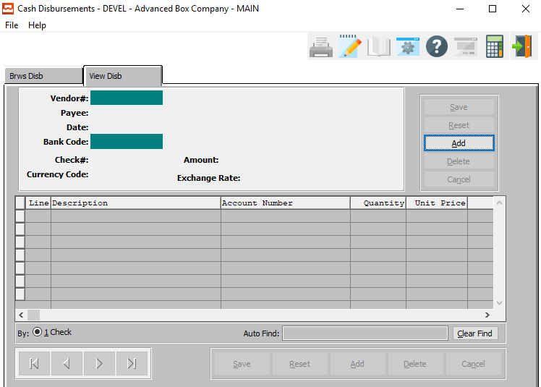

#### ADD

Click the ***“Add”*** button at the top of the screen to add a new Disbursement.

### Add/Update Disbursement

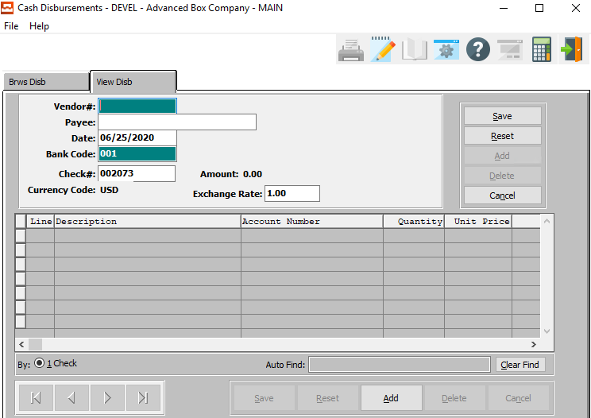

#### SAVE

Click the ***“Save”*** button to save all changes to the current Disbursement.

#### RESET

Click the ***“Reset”*** button to reset all fields to their original state.

#### CANCEL

Click the ***“Cancel”*** button to cancel all changes to the Disbursement without saving.

#### ADD (Line)

Click the ***“Add”*** button at the bottom of the screen to add a new Disbursement Line.

### Add/Update Disbursement Field Definitions

#### Vendor #

Press ***“Enter”*** on the vendor number and you can enter a miscellaneous vendor name in the space provided or you can enter a valid vendor number by one of the following options. Enter the vendor account number, enter the first few characters of vendors name, press the ***“F1”*** key to search for the vendor, or press the ***“Page Up” or “Page Down”*** keys to scroll through the vendor file. Press the ***“Enter”*** key to accept the Vendor number displayed on the screen.

#### Payee

Enter the payee of this disbursement.

#### Date

Enter the date of the check. The system defaults to today's date.

#### Bank Code

For the Bank Account to be used in this transaction, Enter the bank code, press the ***“F1”*** key to search for, or press the ***“Page Up” or “Page Down”*** keys to scroll through the Bank file. Then press the ***“Enter”*** key to accept the bank displayed on the screen.

#### Check #

Enter the check number for this disbursement.

#### Exchange Rate

Enter the exchange rate of this disbursement.

### Add/Update Disbursement Line

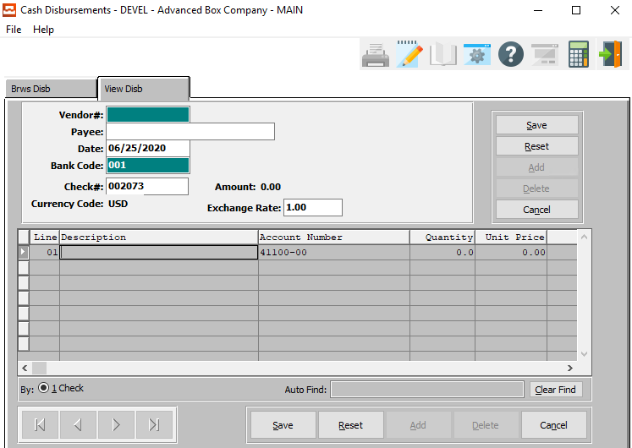

#### SAVE

Click the ***“Save”*** button next to the main information section to save all changes to the current Disbursement.

#### RESET

Click the ***“Reset”*** button next to the main information section to reset all fields to their original state.

#### CANCEL

Click the ***“Cancel”*** button next to the main information section to cancel all changes to the Disbursement without saving.

#### SAVE (Line)

Click the ***“Save”*** button at the bottom of the screen to save all changes to the current Disbursement Line.

#### RESET (Line)

Click the ***“Reset”*** button at the bottom of the screen to reset all fields to their original state.

#### CANCEL (Line)

Click the ***“Cancel”*** button at the bottom of the screen to cancel all changes to the Disbursement Line without saving.

### Add/Update Disbursement Line Field Definitions

#### Line Number

The system maintains the line number sequence of the disbursement. To access the line items, simply press the ***“Enter”*** key when on the due date field.

#### Description

Enter a short description for the disbursement line.

#### Account Number

The system will display the default G/L account number assigned to this vendor in the vendor file. The description will automatically transfer from the G/L Chart of Accounts. If you want to accept the default G/L account number, simply press the ***“Enter”*** key.

To change the G/L account number enter the G/L account number, press the ***“F1”*** function key to search for valid account numbers, or press the ***“Page Up” or “Page Down”*** keys to scroll through the G/L Accounts File. Then press the ***“Enter”*** key to accept the G/L account number displayed on the screen. The system then prompts for the quantity and unit price. Press the ***“Enter”*** key upon entering each of these fields.

The total dollar amount of the line calculates as quantity times unit price. To distribute an expense over several accounts, use as many lines as needed, applying the proper portion to each expense G/L account number. When applying the entire invoice, press the ***“F4”*** function key to end the line item and then press the ***"F"*** (Finish) key to finish this transaction.

#### Quantity

Enter the quantity ordered for this line item. After entering the quantity, press the ***“Enter”*** key. The system then prompts you to enter the unit price. After entering this field, press the ***“Enter”*** key. The total dollar amount of the line calculates as the quantity times the unit price.

To distribute this expense, use as many lines as needed, apply the proper portion to each expense G/L account number. After applying the entire invoice, press the ***“Escape”*** key to end the line item and then press the ***"F"*** (Finish) key to finish this transaction.

#### Unit Price

Enter the unit price for this line item. After entering this field, press the ***“Enter”*** key. The total dollar amount of the line calculates as quantity times unit price. To distribute this expense, use as many lines as needed, apply the proper portion to each expense G/L account number. After applying the entire invoice, press the ***“Escape”*** key to end the line item and then press the ***"F"*** (Finish) key to finish this transaction.

#### Amount

The total dollar amount of the line calculates as quantity multiplied by unit price. To distribute this expense, use as many lines as needed, apply the proper portion to each expense G/L account number. After applying the entire invoice, press the ***“Escape”*** key to end the line item and then press the ***"F"*** (Finish) key to finish this transaction.

## Disbursements Register [VL2]

This report lists all of the unposted disbursements entered into the Disbursements Entry function. After printing all of the checks, you must print and update the check register. This is a summary of all the checks printed in this batch. This report lists the checks in numerical order, with the vendor name, and invoice amount. It also includes totals for each check and the grand total of all checks written.

### Selection Parameters

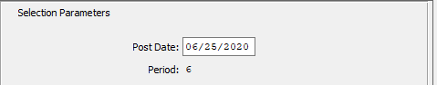

#### Post Date

Enter the date that you want these transactions posted to. Post a transaction, for example, with a date of 12/31/92 either December 1992 or January 1993, depending upon circumstances.

#### Period

This is the period number of the transaction date relative to the fiscal year.

### Date Range and Sorting Order

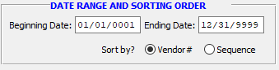

#### Beginning Date / Ending Date

Enter the beginning and ending Date to run the disbursement for.

#### Sort By? (Choice)

To choose the preferred Sorting Method of Vendor Number vs. Sequence Number, please make sure the desired option choice bubble is toggled.

### Output Destination

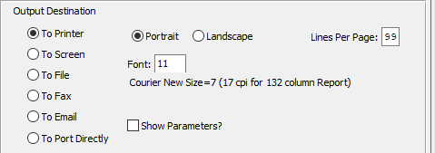

#### Destination Choice

To choose the destination where the document should be printed, please make sure that desired output destination choice bubble is toggled.

#### Layout Choice

To choose the preferred layout of Landscape vs. Portrait, please make sure the desired option choice bubbled is toggled.

#### Lines Per Page

Lines per page on the report when printing.

#### Font

Enter the font number to use with this report (Font 11 is default).

#### Show Parameters? – Toggle Box

To show parameters, make sure that the toggle box is ‘ticked’ with a checkmark.

## Check Register Import [VL3]

This feature is used to import payroll checks printed from MAS 90 Payroll Software, so they can be posted and reconciled. This feature requires programming modification done to import the customers files and is a billable feature. Please call if interested.

### Selection Parameters

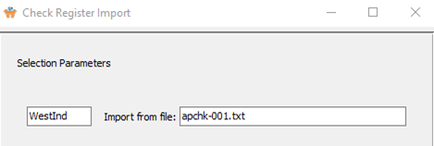

#### Bank Code

Enter a valid bank code for the check register import.

#### Import from File

Enter the MAS 90 payroll file name to import cash disbursements.

# **Query Accounts Payable [VQ]**

On this menu the user has the option of looking at invoice balances by pressing ***“1”*** for Invoice Balances then entering the vendor number you would like to inquire into, entering the first few characters of the vendors number or pressing the ***“F1”***function key to search for a valid vendor. Use the ***“Page Up” or “Page Down”*** keys to scroll through the vendor file.

Press the ***“Enter”*** key when the proper Vendor is Displayed on the screen. You then select the range of invoices you want to inquire into, and whether or not you want only open invoices. All of the invoices in the range selected will display in detail including Invoice amounts, Payments, DB/CR memos and the current invoice balance, after entering this information.

## Invoice Balances [VQ1]

Enter the vendor number you would like to inquire into, enter the first few characters of the vendors number or press the ***“F1”*** function key to search for a valid vendor. Use the ***“Page Up” or “Page Down”*** keys to scroll through the vendor file. Press the ***“Enter”*** key when the proper Vendor is Displayed on the screen. The user may then select the range of invoices you want to inquire into, and whether or not you want only open invoices. All of the invoices in the range selected will display in detail including Invoice amounts, Payments, DB/CR memos and the current invoice balance, after entering this information.

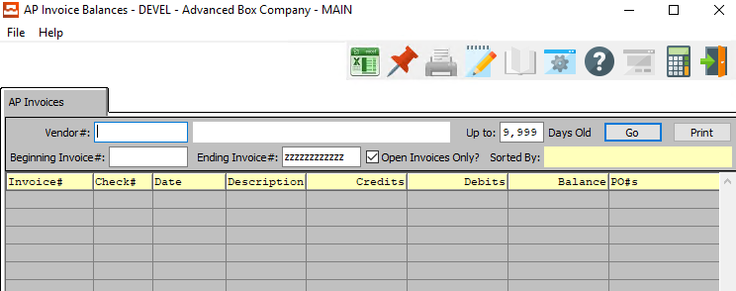

### AP Invoices Field Definitions

#### Vendor #

Enter the vendor number you would like to inquire into, enter the first few characters of the vendors name or Press ***“F1”*** to search for, or use the ***“Page Up” or “Page Down”*** keys to scroll through the vendor file.

#### Vendor Name

The Vendor Name will transfer from the Vendor File as soon as the user enters or chooses a valid vendor number.

#### Beginning Invoice # / Ending Invoice #

Enter a starting and ending invoice numbers or press ***“Enter”*** to use the default starting and ending invoice numbers.

#### Open Invoices Only? – Toggle Box

To only search for open invoices, make sure that the Open Invoices Only toggle box is checked.

#### Number of Days

Enter the number of days old (or less) that you want the system to include in the invoice search for this vendor. For example, if you enter '30' then all invoices less than or equal to 30 days old (by invoice date) will be included in the query.

## Check Invoices [VQ2]

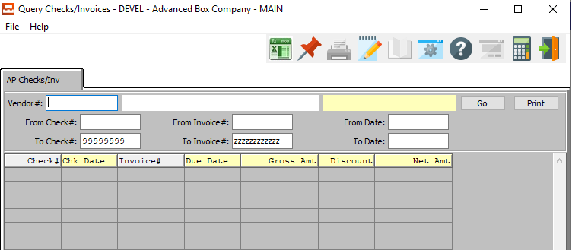

### AP Checks/Invoices Field Definitions

#### Vendor #

Enter the vendor number you would like to inquire into, enter the first few characters of the vendors name or Press ***“F1”*** to search for, or use the ***“Page Up” or “Page Down”*** keys to scroll through the vendor file.

#### Vendor Name

The Vendor Name will transfer from the Vendor File as soon as the user enters or chooses a valid vendor number.

#### From Check # / To Check #

Enter the beginning and ending Check Number to search for.

#### From Invoice # / To Invoice #

Enter the beginning and ending Invoice Number to search for.

#### From Date / To Date

Enter the beginning and ending Date to search for.

## AP Credit/Debit Memos [VQ3]

### Browse CR/DB

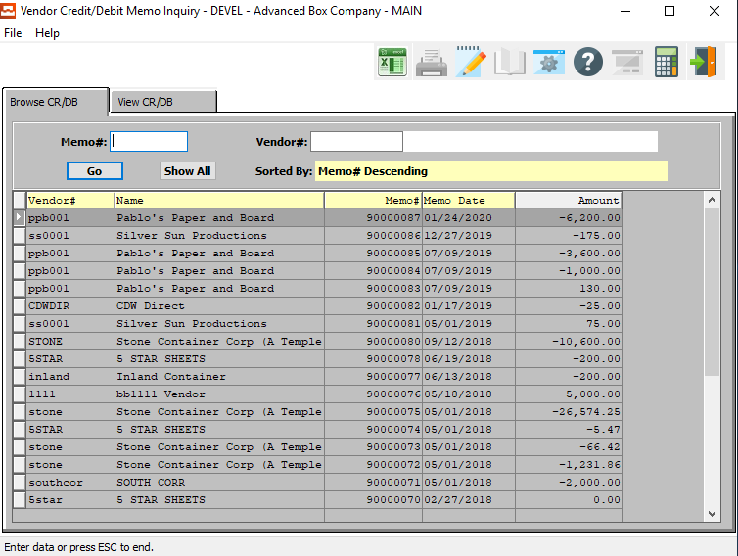

### Browse CR/DB Field Definitions

#### Memo #

Enter a memo number that you would like to use.

#### Vendor #

Enter the vendor number you would like to inquire into, enter the first few characters of the vendors name or Press ***“F1”*** to search for, or use the ***“Page Up” or “Page Down”*** keys to scroll through the vendor file.

#### Vendor Name

The Vendor Name will transfer from the Vendor File as soon as the user enters or chooses a valid vendor number.

### View CR/DB

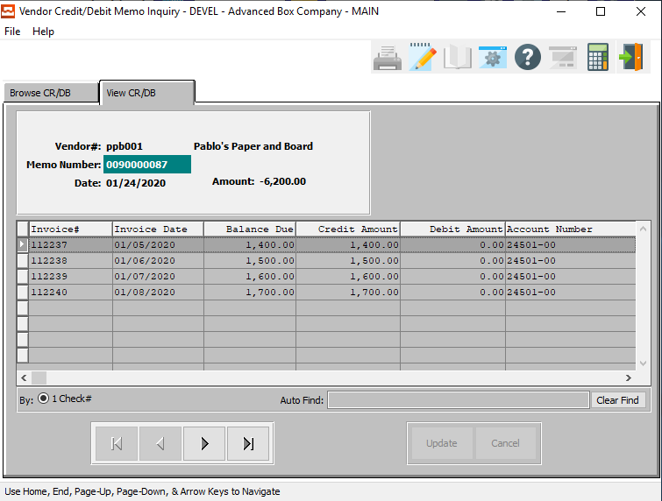

#### NEXT

Press ***"N"*** (Next) to find next Credit/Debit memo to view or modify. Alternatively, press the ***“Right Arrow”*** on the screen.

#### PREVIOUS

Press ***"P"*** (Previous) to find previous Credit/Debit memo to view or modify. Alternatively, press the ***“Left Arrow”*** on the screen.

## AP Invoice Inquiry [VQ4]

### Browse Invoices

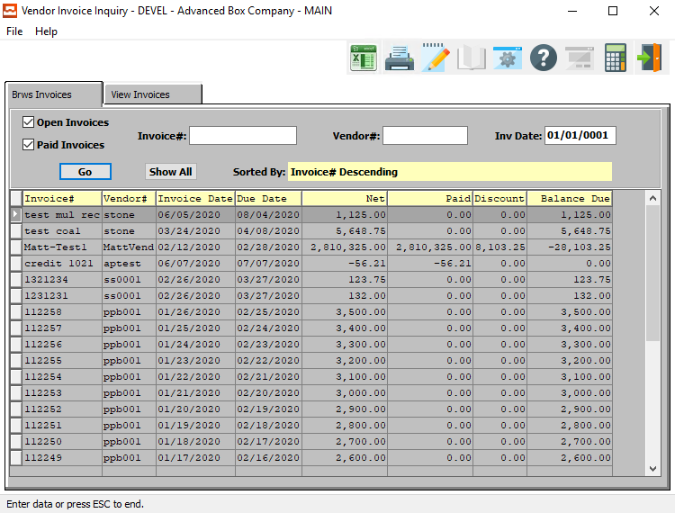

### Browse Invoices Field Definitions

#### Open Invoices – Toggle Box

To search for open invoices, make sure that the Open Invoices toggle box is checked.

#### Paid Invoices – Toggle Box

To search for paid invoices, make sure that the Paid Invoices toggle box is checked.

#### Invoice #

Enter the invoice number for this vendor that you would like to view.

#### Vendor #

Enter the vender number for this invoice. When looking-up a vendor press the ***“F1”*** key and you will get a look-up screen of all vendors available.

#### Invoice Date

Enter the invoice date for the vendor.

### View Invoices

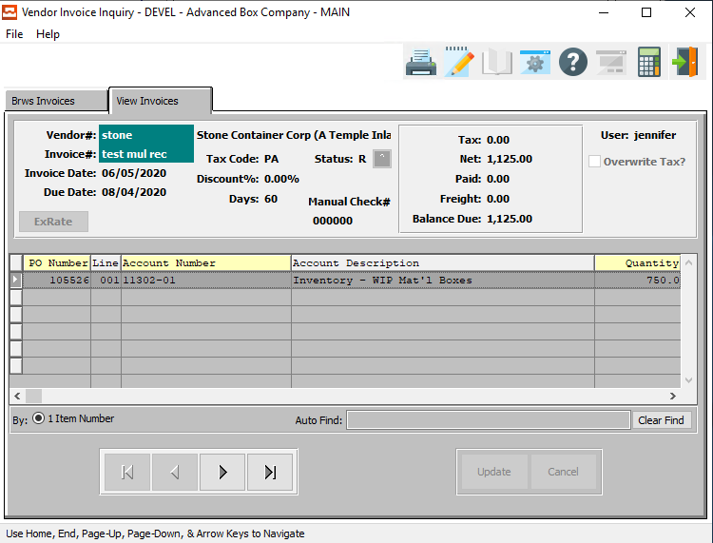

#### NEXT

Press ***"N"*** (Next) to find next invoice to view or modify. Alternatively, press the ***“Right Arrow”*** on the screen.

#### PREVIOUS

Press ***"P"*** (Previous) to find previous invoice to view or modify. Alternatively, press the ***“Left Arrow”*** on the screen.

# **Reports for Payables [VR]**

## Overview

The Vendor Aging report will print in Vendor number sequence and list outstanding invoices from each vendor. The report groups Payables according to the number of days past due. The Cash Requirements report prompts you to enter three separate dates. After entering each date, press the ***“Enter”*** key. The report will then print, by vendor, the amount of cash required to pay Open Payables.

The Vendor Analysis report lists all vendors in vendor number order, the total amount due for each vendor along with MTD, YTD, Last Year and variance information. The Vendor Master List report prints in vendor number sequence and lists all vendors and information requested by user on the screen.

The Credit/Debit and Purchase by GL Account report lists all cash disbursements and purchases made for the range selected and lists them in general ledger account number order. The report includes the posting date of each transaction, invoice number, check number, order number, quantity, amount MSF, discount and amount of purchase.

The Mailing List report enables the user to print a mailing list or run labels. The Monthly Tax Report, Tax Distribution Schedule and the MTD Destination Subtotal all print a list of Net sales and total tax due for all jurisdictions selected for a particular month. The Tax Schedule by Customer Report List in customer name, orders all taxes due@@.

## Vendor Aging [VR1]

This report will print in Vendor number sequence and list outstanding invoices from each vendor. The report groups Payables according to the number of days past due (i.e., 'Current', '30 days old', etc.).

### Selection Parameters

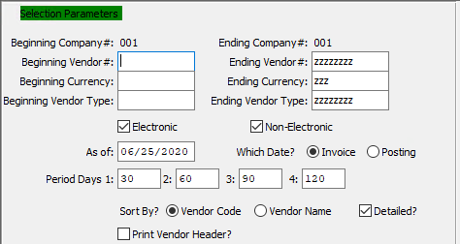

#### Beginning Vendor # / Ending Vendor #

Enter a starting and an ending range of vendors.

#### Beginning Currency / Ending Currency

Enter the beginning and ending currency code to run the aging report for.

#### Beginning Vendor Type / Ending Vendor Type

Enter the beginning and ending Vendor Type to run the aging report for.

#### Electronic – Toggle Box

To run the aging report for electronic checks, make sure that the Electronic toggle box is checked.

#### Non-Electronic – Toggle Box

To run the aging report for non-electronic checks, make sure that the Non-Electronic toggle box is checked.

#### As Of

Enter a valid date. The report will list all invoices up to and including this date selected. As of today, the user cannot get a report from a prior month that has been closed. The as-of date must be within the current month open.

#### Which Date? (Choice)

To choose the preferred date type to search for between Invoice Date vs. Posting Date, please make sure the desired option choice bubble is toggled.

#### Period Days (1-4)

Enter the number of days on which the selected period ends.

#### Sort By? (Choice)

To choose the preferred sorting method of Vendor Code vs. Vendor Name, please make sure the desired option choice bubble is toggled.

#### Print Vendor Header? – Toggle Box

To print the Vendor’s header on the aging report, make sure that the Print Vendor Header toggle box is checked.

### Available and Selected Columns

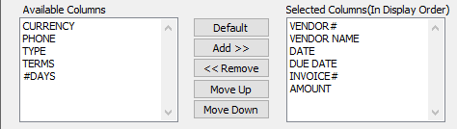

#### Available Columns

The user may choose which columns they wish to have on the report printout. As the user selects their choices, they will appear on the ‘*Selected Columns’* list.

#### Selected Columns (In Display Order)

The columns that the user has chosen from the ‘*Available Columns’* list. The order that these columns are displayed in here is the order in which they will print on the report.

#### Default

Click the ***“Default****”* button to sort the ‘*Selected Columns’* list by the default system parameters.

#### Add >>

Click on the selected item from the ‘*Available Columns’* list to highlight it, then click the ***“Add”*** button to add the selected column to the ‘*Selected Columns’* list.

#### << Remove

Click on the selected item from the ‘*Selected Columns’* list to highlight it, then click the ***“Remove”*** button to remove the selected column to the ‘*Selected Columns’* list.

#### Move Up

Within the ‘*Selected Columns’* list, the user may choose the order they wish the selected columns to print in. In order to change the order of the columns, the user can click on a selection to highlight it. By then clicking the ***“Move Up***” button, the user can change its position on the report.

#### Move Down

Within the ‘*Selected Columns’* list, the user may choose the order they wish the selected columns to print in. In order to change the order of the columns, the user can click on a selection to highlight it. By then clicking the ***“Move Down***” button, the user can change its position on the report.

### Output Destination

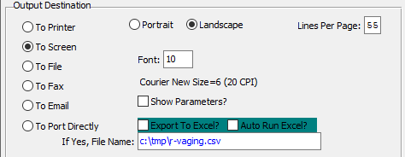

#### Destination Choice

To choose the destination where the document should be printed, please make sure that desired output destination choice bubble is toggled.

#### Layout Choice

To choose the preferred layout of Landscape vs. Portrait, please make sure the desired option choice bubbled is toggled.

#### Lines Per Page

Lines per page on the report when printing.

#### Font

Enter the font number to use with this report (Font 11 is default).

#### Show Parameters? – Toggle Box

To show parameters, make sure that the toggle box is ‘ticked’ with a checkmark.

#### Export to Excel? – Toggle Box

To export the printed file to an excel document, make sure that the Export to Excel toggle box is checked.

#### Auto Run Excel? – Toggle Box

To automatically open the new excel document, make sure that the Auto Run Excel toggle box is checked.

#### If Yes, File Name

If exporting the file to Excel, enter the desired file name.

## AR Cash Requirements [VR2]

The Cash requirements report prompts you to enter three separate dates. After entering each date, press the ***“Enter”*** key. The report will then print, by vendor, the amount of cash required to pay Open Payables.

### Selection Parameters

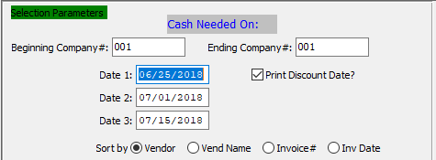

#### Beginning Customer # / Ending Customer #

Enter the beginning and ending Company Number to run the cash requirements report for.

#### Dates (1-1)

Enter the dates the cash is needed on.

#### Print Discount Date? – Toggle Box

To print the discount date on the report, make sure that the Print Discount Date toggle box is checked.

#### Sort By (Choice)

To choose the preferred sorting method, please make sure the desired option choice bubble is toggled.

### Available and Selected Columns

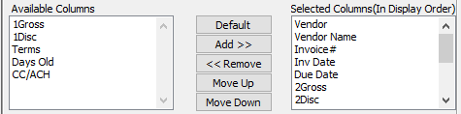

#### Available Columns

The user may choose which columns they wish to have on the report printout. As the user selects their choices, they will appear on the ‘*Selected Columns’* list.

#### Selected Columns (In Display Order)

The columns that the user has chosen from the ‘*Available Columns’* list. The order that these columns are displayed in here is the order in which they will print on the report.

#### Default

Click the ***“Default****”* button to sort the ‘*Selected Columns’* list by the default system parameters.

#### Add >>

Click on the selected item from the ‘*Available Columns’* list to highlight it, then click the ***“Add”*** button to add the selected column to the ‘*Selected Columns’* list.

#### << Remove

Click on the selected item from the ‘*Selected Columns’* list to highlight it, then click the ***“Remove”*** button to remove the selected column to the ‘*Selected Columns’* list.

#### Move Up

Within the ‘*Selected Columns’* list, the user may choose the order they wish the selected columns to print in. In order to change the order of the columns, the user can click on a selection to highlight it. By then clicking the ***“Move Up***” button, the user can change its position on the report.

#### Move Down

Within the ‘*Selected Columns’* list, the user may choose the order they wish the selected columns to print in. In order to change the order of the columns, the user can click on a selection to highlight it. By then clicking the ***“Move Down***” button, the user can change its position on the report.

### Output Destination

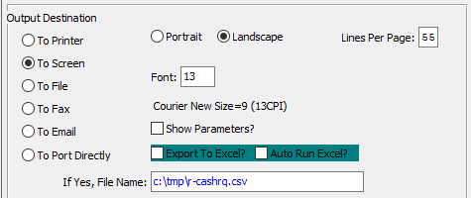

#### Destination Choice

To choose the destination where the document should be printed, please make sure that desired output destination choice bubble is toggled.

#### Layout Choice

To choose the preferred layout of Landscape vs. Portrait, please make sure the desired option choice bubbled is toggled.

#### Lines Per Page

Lines per page on the report when printing.

#### Font

Enter the font number to use with this report (Font 11 is default).

#### Show Parameters? – Toggle Box

To show parameters, make sure that the toggle box is ‘ticked’ with a checkmark.

#### Export to Excel? – Toggle Box

To export the printed file to an excel document, make sure that the Export to Excel toggle box is checked.

#### Auto Run Excel? – Toggle Box

To automatically open the new excel document, make sure that the Auto Run Excel toggle box is checked.

#### If Yes, File Name

If exporting the file to Excel, enter the desired file name.

## AP Vendor Analysis [VR3]

This report lists all vendors in vendor number order, the total amount due for each vendor along with MTD, YTD, Last Year and variance information.

### Selection Parameters

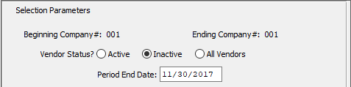

#### Vendor Status? (Choice)

Enter ending date to run report.

#### Period End Date

Enter the period end date to run the vendor analysis report for.

### Available and Selected Columns

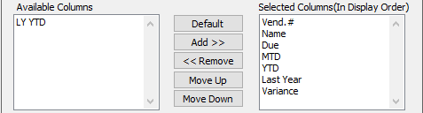

#### Available Columns

The user may choose which columns they wish to have on the report printout. As the user selects their choices, they will appear on the ‘*Selected Columns’* list.

#### Selected Columns (In Display Order)

The columns that the user has chosen from the ‘*Available Columns’* list. The order that these columns are displayed in here is the order in which they will print on the report.

#### Default

Click the ***“Default****”* button to sort the ‘*Selected Columns’* list by the default system parameters.

#### Add >>

Click on the selected item from the ‘*Available Columns’* list to highlight it, then click the ***“Add”*** button to add the selected column to the ‘*Selected Columns’* list.

#### << Remove

Click on the selected item from the ‘*Selected Columns’* list to highlight it, then click the ***“Remove”*** button to remove the selected column to the ‘*Selected Columns’* list.

#### Move Up

Within the ‘*Selected Columns’* list, the user may choose the order they wish the selected columns to print in. In order to change the order of the columns, the user can click on a selection to highlight it. By then clicking the ***“Move Up***” button, the user can change its position on the report.

#### Move Down

Within the ‘*Selected Columns’* list, the user may choose the order they wish the selected columns to print in. In order to change the order of the columns, the user can click on a selection to highlight it. By then clicking the ***“Move Down***” button, the user can change its position on the report.

### Output Destination

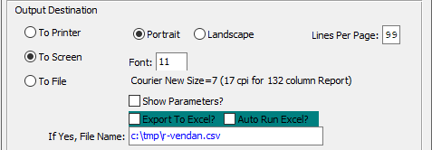

#### Destination Choice

To choose the destination where the document should be printed, please make sure that desired output destination choice bubble is toggled.

#### Layout Choice

To choose the preferred layout of Landscape vs. Portrait, please make sure the desired option choice bubbled is toggled.

#### Lines Per Page

Lines per page on the report when printing.

#### Font

Enter the font number to use with this report (Font 11 is default).

#### Show Parameters? – Toggle Box

To show parameters, make sure that the toggle box is ‘ticked’ with a checkmark.

#### Export to Excel? – Toggle Box

To export the printed file to an excel document, make sure that the Export to Excel toggle box is checked.

#### Auto Run Excel? – Toggle Box

To automatically open the new excel document, make sure that the Auto Run Excel toggle box is checked.

#### If Yes, File Name

If exporting the file to Excel, enter the desired file name.

## Vendor Master List [VR4]

This report prints in vendor number sequence and lists all vendors and information requested by the user.

### Selection Parameters

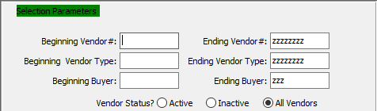

#### Beginning Vendor # / Ending Vendor #

Enter the beginning and ending Vendor Number to run the Master List report for.

#### Beginning Vendor Type / Ending Vendor Type

Enter the beginning and ending Vendor Type to run the Master List report for.

#### Beginning Buyer / Ending Buyer

Enter the beginning and ending Buyer Code to run the Master List report for.

#### Vendor Status? (Choice)

To choose the preferred Vendor Status of Active vs. Inactive (Or All), please make sure the desired option choice bubble is toggled.

### Available and Selected Columns

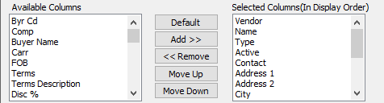

#### Available Columns

The user may choose which columns they wish to have on the report printout. As the user selects their choices, they will appear on the ‘*Selected Columns’* list.

#### Selected Columns (In Display Order)

The columns that the user has chosen from the ‘*Available Columns’* list. The order that these columns are displayed in here is the order in which they will print on the report.

#### Default

Click the ***“Default****”* button to sort the ‘*Selected Columns’* list by the default system parameters.

#### Add >>

Click on the selected item from the ‘*Available Columns’* list to highlight it, then click the ***“Add”*** button to add the selected column to the ‘*Selected Columns’* list.

#### << Remove

Click on the selected item from the ‘*Selected Columns’* list to highlight it, then click the ***“Remove”*** button to remove the selected column to the ‘*Selected Columns’* list.

#### Move Up

Within the ‘*Selected Columns’* list, the user may choose the order they wish the selected columns to print in. In order to change the order of the columns, the user can click on a selection to highlight it. By then clicking the ***“Move Up***” button, the user can change its position on the report.

#### Move Down

Within the ‘*Selected Columns’* list, the user may choose the order they wish the selected columns to print in. In order to change the order of the columns, the user can click on a selection to highlight it. By then clicking the ***“Move Down***” button, the user can change its position on the report.

### Output Destination

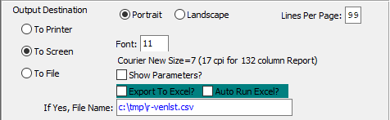

#### Destination Choice

To choose the destination where the document should be printed, please make sure that desired output destination choice bubble is toggled.

#### Layout Choice

To choose the preferred layout of Landscape vs. Portrait, please make sure the desired option choice bubbled is toggled.

#### Lines Per Page

Lines per page on the report when printing.

#### Font

Enter the font number to use with this report (Font 11 is default).

#### Show Parameters? – Toggle Box

To show parameters, make sure that the toggle box is ‘ticked’ with a checkmark.

#### Export to Excel? – Toggle Box

To export the printed file to an excel document, make sure that the Export to Excel toggle box is checked.

#### Auto Run Excel? – Toggle Box

To automatically open the new excel document, make sure that the Auto Run Excel toggle box is checked.

## AP Mailing List [VR5]

This report enables the user to print a mailing list or run labels.

### Selection Parameters

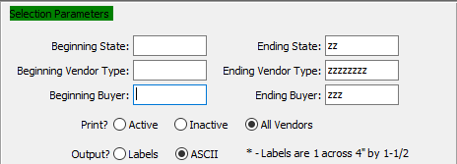

#### Beginning State / Ending State

Enter the starting and ending state abbreviation.

#### Beginning Vendor Type / Ending Vendor Type

Enter the beginning and ending type defined in the vendor type file.

#### Beginning Buyer / Ending Buyer

Enter the beginning and ending buyer code defined in the vendor buyer file.

#### Print? (Choice)

To choose the preferred Print Option of Active Vendor vs. Inactive Vendor (Or All), please make sure the desired option choice bubble is toggled.

#### Output? (Choice)

To choose the preferred output option of Labels vs. ASCII, please make sure the desired option choice bubble is toggled.

### Available and Selected Columns

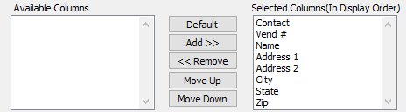

#### Available Columns

The user may choose which columns they wish to have on the report printout. As the user selects their choices, they will appear on the ‘*Selected Columns’* list.

#### Selected Columns (In Display Order)

The columns that the user has chosen from the ‘*Available Columns’* list. The order that these columns are displayed in here is the order in which they will print on the report.

#### Default

Click the ***“Default****”* button to sort the ‘*Selected Columns’* list by the default system parameters.

#### Add >>

Click on the selected item from the ‘*Available Columns’* list to highlight it, then click the ***“Add”*** button to add the selected column to the ‘*Selected Columns’* list.

#### << Remove

Click on the selected item from the ‘*Selected Columns’* list to highlight it, then click the ***“Remove”*** button to remove the selected column to the ‘*Selected Columns’* list.

#### Move Up

Within the ‘*Selected Columns’* list, the user may choose the order they wish the selected columns to print in. In order to change the order of the columns, the user can click on a selection to highlight it. By then clicking the ***“Move Up***” button, the user can change its position on the report.

#### Move Down

Within the ‘*Selected Columns’* list, the user may choose the order they wish the selected columns to print in. In order to change the order of the columns, the user can click on a selection to highlight it. By then clicking the ***“Move Down***” button, the user can change its position on the report.

### Output Destination

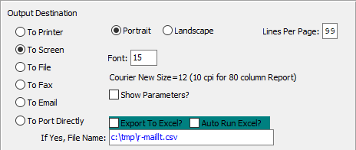

#### Destination Choice

To choose the destination where the document should be printed, please make sure that desired output destination choice bubble is toggled.

#### Layout Choice

To choose the preferred layout of Landscape vs. Portrait, please make sure the desired option choice bubbled is toggled.

#### Lines Per Page

Lines per page on the report when printing.

#### Font

Enter the font number to use with this report (Font 11 is default).

#### Show Parameters? – Toggle Box

To show parameters, make sure that the toggle box is ‘ticked’ with a checkmark.

#### Export to Excel? – Toggle Box

To export the printed file to an excel document, make sure that the Export to Excel toggle box is checked.

#### Auto Run Excel? – Toggle Box

To automatically open the new excel document, make sure that the Auto Run Excel toggle box is checked.

#### If Yes, File Name

If exporting the file to Excel, enter the desired file name.

## Monthly Tax [VR6]

This report displays Gross sales and total tax for each tax jurisdiction for period selected.

### Selection Parameters

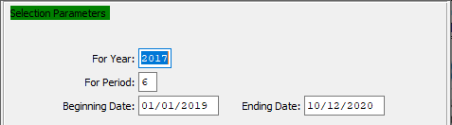

#### For Year

Enter a valid year to run the monthly tax report for.

#### For Period

Enter a valid period to run the monthly tax report for.

#### Beginning Date / Ending Date

These dates will default from period selected.

### Output Destination

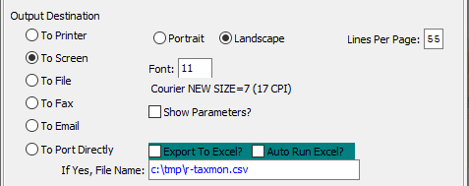

#### Destination Choice

To choose the destination where the document should be printed, please make sure that desired output destination choice bubble is toggled.

#### Layout Choice

To choose the preferred layout of Landscape vs. Portrait, please make sure the desired option choice bubbled is toggled.

#### Show Parameters? – Toggle Box

To show parameters, make sure that the toggle box is ‘ticked’ with a checkmark.

#### Export to Excel? – Toggle Box

To export the printed file to an excel document, make sure that the Export to Excel toggle box is checked.

#### Auto Run Excel? – Toggle Box

To automatically open the new excel document, make sure that the Auto Run Excel toggle box is checked.

## Tax Distribution Schedule [VR7]

This report displays Sales Total before Tax and total tax for each tax jurisdiction for period selected. It prints a separate page for each Jurisdiction.

### Selection Parameters

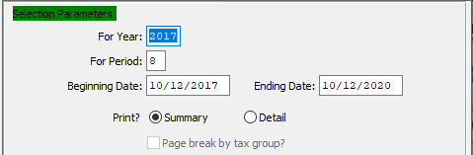

#### For Year

Enter a valid year to run the tax distribution report for.

#### For Period

Enter a valid period to run the tax distribution report for.

#### Beginning Date / Ending Date

These dates will default from period selected.

#### Print? (Choice)

To choose the preferred Print Method of Summary vs. Detailed, please make sure the desired option choice bubble is toggled.

### Available and Selected Columns

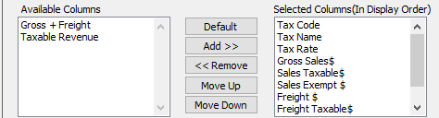

#### Available Columns

The user may choose which columns they wish to have on the report printout. As the user selects their choices, they will appear on the ‘*Selected Columns’* list.

#### Selected Columns (In Display Order)

The columns that the user has chosen from the ‘*Available Columns’* list. The order that these columns are displayed in here is the order in which they will print on the report.

#### Default

Click the ***“Default****”* button to sort the ‘*Selected Columns’* list by the default system parameters.

#### Add >>

Click on the selected item from the ‘*Available Columns’* list to highlight it, then click the ***“Add”*** button to add the selected column to the ‘*Selected Columns’* list.

#### << Remove

Click on the selected item from the ‘*Selected Columns’* list to highlight it, then click the ***“Remove”*** button to remove the selected column to the ‘*Selected Columns’* list.

#### Move Up

Within the ‘*Selected Columns’* list, the user may choose the order they wish the selected columns to print in. In order to change the order of the columns, the user can click on a selection to highlight it. By then clicking the ***“Move Up***” button, the user can change its position on the report.

#### Move Down

Within the ‘*Selected Columns’* list, the user may choose the order they wish the selected columns to print in. In order to change the order of the columns, the user can click on a selection to highlight it. By then clicking the ***“Move Down***” button, the user can change its position on the report.

### Output Destination

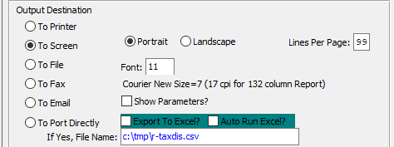

#### Destination Choice

To choose the destination where the document should be printed, please make sure that desired output destination choice bubble is toggled.

#### Layout Choice

To choose the preferred layout of Landscape vs. Portrait, please make sure the desired option choice bubbled is toggled.

#### Lines Per Page

Lines per page on the report when printing.

#### Font

Enter the font number to use with this report (Font 11 is default).

#### Show Parameters? – Toggle Box

To show parameters, make sure that the toggle box is ‘ticked’ with a checkmark.

#### Export to Excel? – Toggle Box

To export the printed file to an excel document, make sure that the Export to Excel toggle box is checked.

#### Auto Run Excel? – Toggle Box

To automatically open the new excel document, make sure that the Auto Run Excel toggle box is checked.

## MTD Destination Subtotals [VR8]

This report displays Sales Total before Tax and total tax for each tax jurisdiction for period selected.

### Selection Parameters

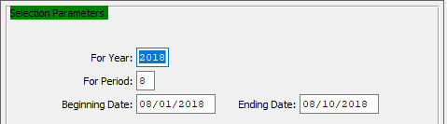

#### For Year

Enter a valid year to run the MTD destination subtotal report for.

#### For Period

Enter a valid period to run the MTD destination subtotal report for.

#### Beginning Date / Ending Date

These dates will default from period selected.

### Available and Selected Columns

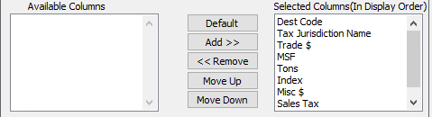

#### Available Columns

The user may choose which columns they wish to have on the report printout. As the user selects their choices, they will appear on the ‘*Selected Columns’* list.

#### Selected Columns (In Display Order)

The columns that the user has chosen from the ‘*Available Columns’* list. The order that these columns are displayed in here is the order in which they will print on the report.

#### Default

Click the ***“Default****”* button to sort the ‘*Selected Columns’* list by the default system parameters.

#### Add >>

Click on the selected item from the ‘*Available Columns’* list to highlight it, then click the ***“Add”*** button to add the selected column to the ‘*Selected Columns’* list.

#### << Remove

Click on the selected item from the ‘*Selected Columns’* list to highlight it, then click the ***“Remove”*** button to remove the selected column to the ‘*Selected Columns’* list.

#### Move Up

Within the ‘*Selected Columns’* list, the user may choose the order they wish the selected columns to print in. In order to change the order of the columns, the user can click on a selection to highlight it. By then clicking the ***“Move Up***” button, the user can change its position on the report.

#### Move Down

Within the ‘*Selected Columns’* list, the user may choose the order they wish the selected columns to print in. In order to change the order of the columns, the user can click on a selection to highlight it. By then clicking the ***“Move Down***” button, the user can change its position on the report.

### Output Destination

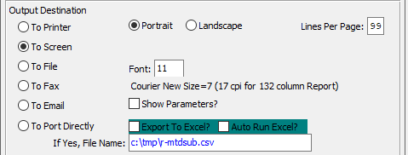

#### Destination Choice

To choose the destination where the document should be printed, please make sure that desired output destination choice bubble is toggled.

#### Layout Choice

To choose the preferred layout of Landscape vs. Portrait, please make sure the desired option choice bubbled is toggled.

#### Lines Per Page

Lines per page on the report when printing.

#### Font

Enter the font number to use with this report (Font 11 is default).

#### Show Parameters? – Toggle Box

To show parameters, make sure that the toggle box is ‘ticked’ with a checkmark.

#### Export to Excel? – Toggle Box

To export the printed file to an excel document, make sure that the Export to Excel toggle box is checked.

#### Auto Run Excel? – Toggle Box

To automatically open the new excel document, make sure that the Auto Run Excel toggle box is checked.

#### If Yes, File Name

If exporting the file to Excel, enter the desired file name.

## Tax Schedule by Customer [VR9]

This report displays all sales totals before tax and total tax for each tax jurisdiction in customer name order for period selected.

### Selection Parameters

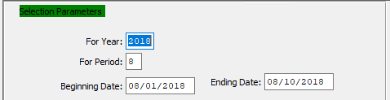

#### For Year

Enter a valid year to run the tax schedule report for.

#### For Period

Enter a valid period to run the tax schedule report for.

#### Beginning Date / Ending Date

These dates will default from period selected.

### Available and Selected Columns

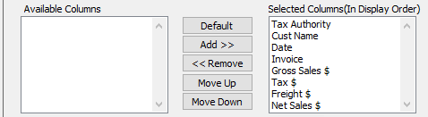

#### Available Columns

The user may choose which columns they wish to have on the report printout. As the user selects their choices, they will appear on the ‘*Selected Columns’* list.

#### Selected Columns (In Display Order)

The columns that the user has chosen from the ‘*Available Columns’* list. The order that these columns are displayed in here is the order in which they will print on the report.

#### Default

Click the ***“Default****”* button to sort the ‘*Selected Columns’* list by the default system parameters.

#### Add >>

Click on the selected item from the ‘*Available Columns’* list to highlight it, then click the ***“Add”*** button to add the selected column to the ‘*Selected Columns’* list.

#### << Remove

Click on the selected item from the ‘*Selected Columns’* list to highlight it, then click the ***“Remove”*** button to remove the selected column to the ‘*Selected Columns’* list.

#### Move Up

Within the ‘*Selected Columns’* list, the user may choose the order they wish the selected columns to print in. In order to change the order of the columns, the user can click on a selection to highlight it. By then clicking the ***“Move Up***” button, the user can change its position on the report.

#### Move Down

Within the ‘*Selected Columns’* list, the user may choose the order they wish the selected columns to print in. In order to change the order of the columns, the user can click on a selection to highlight it. By then clicking the ***“Move Down***” button, the user can change its position on the report.

### Output Destination

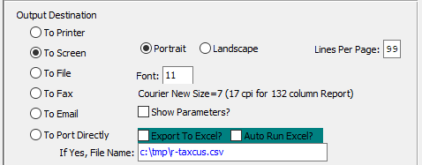

#### Destination Choice

To choose the destination where the document should be printed, please make sure that desired output destination choice bubble is toggled.

#### Layout Choice

To choose the preferred layout of Landscape vs. Portrait, please make sure the desired option choice bubbled is toggled.

#### Lines Per Page

Lines per page on the report when printing.

#### Font

Enter the font number to use with this report (Font 11 is default).

#### Show Parameters? – Toggle Box

To show parameters, make sure that the toggle box is ‘ticked’ with a checkmark.

#### Export to Excel? – Toggle Box

To export the printed file to an excel document, make sure that the Export to Excel toggle box is checked.

#### Auto Run Excel? – Toggle Box

To automatically open the new excel document, make sure that the Auto Run Excel toggle box is checked.

#### If Yes, File Name

If exporting the file to Excel, enter the desired file name.

## Vendor 1099 Report [VR)]

### Selection Parameters

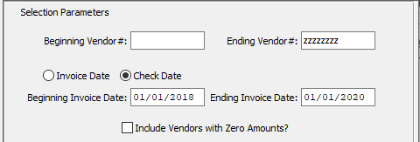

#### Beginning Vendor # / Ending Vendor #

Enter the beginning and ending Vendor Number to run the report for.

#### Date (Choice)

To choose the preferred date option of Invoice Date vs. Check Date, please make sure the desired option choice bubble is toggled.

#### Beginning Invoice Date / Ending Invoice Date

Enter the beginning and ending Invoice Date to run the report for.

#### Include Vendors with Zero Amounts? – Toggle Box

To include vendors with no accounts in the 1099 report, make sure that this toggle box is checked.

### Available and Selected Columns

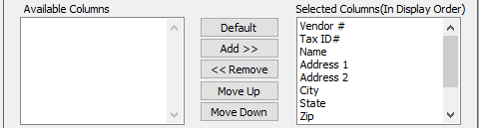

#### Available Columns

The user may choose which columns they wish to have on the report printout. As the user selects their choices, they will appear on the ‘*Selected Columns’* list.

#### Selected Columns (In Display Order)

The columns that the user has chosen from the ‘*Available Columns’* list. The order that these columns are displayed in here is the order in which they will print on the report.

#### Default

Click the ***“Default****”* button to sort the ‘*Selected Columns’* list by the default system parameters.

#### Add >>

Click on the selected item from the ‘*Available Columns’* list to highlight it, then click the ***“Add”*** button to add the selected column to the ‘*Selected Columns’* list.

#### << Remove

Click on the selected item from the ‘*Selected Columns’* list to highlight it, then click the ***“Remove”*** button to remove the selected column to the ‘*Selected Columns’* list.

#### Move Up

Within the ‘*Selected Columns’* list, the user may choose the order they wish the selected columns to print in. In order to change the order of the columns, the user can click on a selection to highlight it. By then clicking the ***“Move Up***” button, the user can change its position on the report.

#### Move Down

Within the ‘*Selected Columns’* list, the user may choose the order they wish the selected columns to print in. In order to change the order of the columns, the user can click on a selection to highlight it. By then clicking the ***“Move Down***” button, the user can change its position on the report.

### Output Destination

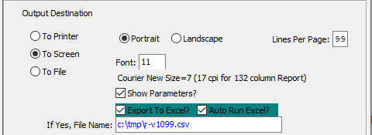

#### Destination Choice

To choose the destination where the document should be printed, please make sure that desired output destination choice bubble is toggled.

#### Layout Choice

To choose the preferred layout of Landscape vs. Portrait, please make sure the desired option choice bubbled is toggled.

#### Lines Per Page

Lines per page on the report when printing.

#### Font

Enter the font number to use with this report (Font 11 is default).

#### Show Parameters? – Toggle Box

To show parameters, make sure that the toggle box is ‘ticked’ with a checkmark.

#### Export to Excel? – Toggle Box

To export the printed file to an excel document, make sure that the Export to Excel toggle box is checked.

#### Auto Run Excel? – Toggle Box

To automatically open the new excel document, make sure that the Auto Run Excel toggle box is checked.

#### If Yes, File Name

If exporting the file to Excel, enter the desired file name.

## AP Accounts by Vendor [VR!]

### Selection Parameters

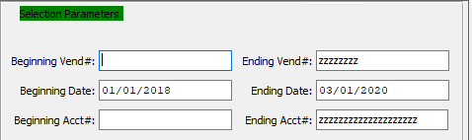

#### Beginning Vendor # / Ending Vendor #

Enter the beginning and ending Vendor Number to run the report for.

#### Beginning Date / Ending Date

Enter the beginning and ending Date to run the report for.

#### Beginning Account # / Ending Account #

Enter the beginning and ending Account Number to run the report for.

### Available and Selected Columns

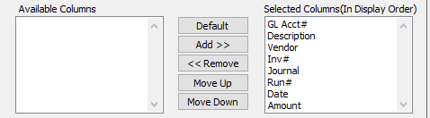

#### Available Columns

The user may choose which columns they wish to have on the report printout. As the user selects their choices, they will appear on the ‘*Selected Columns’* list.

#### Selected Columns (In Display Order)

The columns that the user has chosen from the ‘*Available Columns’* list. The order that these columns are displayed in here is the order in which they will print on the report.

#### Default

Click the ***“Default****”* button to sort the ‘*Selected Columns’* list by the default system parameters.

#### Add >>

Click on the selected item from the ‘*Available Columns’* list to highlight it, then click the ***“Add”*** button to add the selected column to the ‘*Selected Columns’* list.

#### << Remove

Click on the selected item from the ‘*Selected Columns’* list to highlight it, then click the ***“Remove”*** button to remove the selected column to the ‘*Selected Columns’* list.

#### Move Up

Within the ‘*Selected Columns’* list, the user may choose the order they wish the selected columns to print in. In order to change the order of the columns, the user can click on a selection to highlight it. By then clicking the ***“Move Up***” button, the user can change its position on the report.

#### Move Down

Within the ‘*Selected Columns’* list, the user may choose the order they wish the selected columns to print in. In order to change the order of the columns, the user can click on a selection to highlight it. By then clicking the ***“Move Down***” button, the user can change its position on the report.

### Output Destination

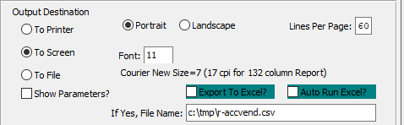

#### Destination Choice

To choose the destination where the document should be printed, please make sure that desired output destination choice bubble is toggled.

#### Layout Choice

To choose the preferred layout of Landscape vs. Portrait, please make sure the desired option choice bubbled is toggled.

#### Lines Per Page

Lines per page on the report when printing.

#### Font

Enter the font number to use with this report (Font 11 is default).

#### Show Parameters? – Toggle Box

To show parameters, make sure that the toggle box is ‘ticked’ with a checkmark.

#### Export to Excel? – Toggle Box

To export the printed file to an excel document, make sure that the Export to Excel toggle box is checked.

#### Auto Run Excel? – Toggle Box

To automatically open the new excel document, make sure that the Auto Run Excel toggle box is checked.

#### If Yes, File Name

If exporting the file to Excel, enter the desired file name.

## AP Invoices by Vendor [VR@]

### Selection Parameters

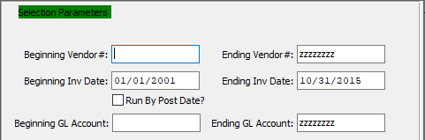

#### Beginning Vendor # / Ending Vendor #

Enter the beginning and ending Vendor Number to run the report for.

#### Beginning Invoice Date / Ending Invoice Date

Enter the beginning and ending Invoice Date to run the report for.

#### Run by Post Date? – Toggle Box

To run the report by posting date, make sure that the Run by Posts Date toggle box is checked.

#### Beginning GL Account / Ending GL Account

Enter the beginning and ending General Ledger Account to run the report for.

### Available and Selected Columns

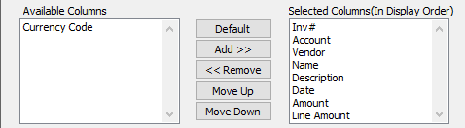

#### Available Columns

The user may choose which columns they wish to have on the report printout. As the user selects their choices, they will appear on the ‘*Selected Columns’* list.

#### Selected Columns (In Display Order)

The columns that the user has chosen from the ‘*Available Columns’* list. The order that these columns are displayed in here is the order in which they will print on the report.

#### Default

Click the ***“Default****”* button to sort the ‘*Selected Columns’* list by the default system parameters.

#### Add >>

Click on the selected item from the ‘*Available Columns’* list to highlight it, then click the ***“Add”*** button to add the selected column to the ‘*Selected Columns’* list.

#### << Remove

Click on the selected item from the ‘*Selected Columns’* list to highlight it, then click the ***“Remove”*** button to remove the selected column to the ‘*Selected Columns’* list.

#### Move Up

Within the ‘*Selected Columns’* list, the user may choose the order they wish the selected columns to print in. In order to change the order of the columns, the user can click on a selection to highlight it. By then clicking the ***“Move Up***” button, the user can change its position on the report.

#### Move Down

Within the ‘*Selected Columns’* list, the user may choose the order they wish the selected columns to print in. In order to change the order of the columns, the user can click on a selection to highlight it. By then clicking the ***“Move Down***” button, the user can change its position on the report.

### Output Destination

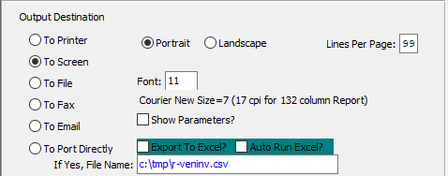

#### Destination Choice

To choose the destination where the document should be printed, please make sure that desired output destination choice bubble is toggled.

#### Layout Choice

To choose the preferred layout of Landscape vs. Portrait, please make sure the desired option choice bubbled is toggled.

#### Lines Per Page

Lines per page on the report when printing.

#### Font

Enter the font number to use with this report (Font 11 is default).

#### Show Parameters? – Toggle Box

To show parameters, make sure that the toggle box is ‘ticked’ with a checkmark.

#### Export to Excel? – Toggle Box

To export the printed file to an excel document, make sure that the Export to Excel toggle box is checked.

#### Auto Run Excel? – Toggle Box

To automatically open the new excel document, make sure that the Auto Run Excel toggle box is checked.

#### If Yes, File Name

If exporting the file to Excel, enter the desired file name.

## AP Check Register [VR#]

### Selection Parameters

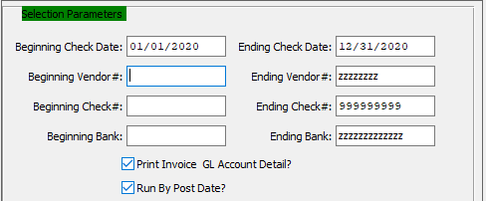

#### Beginning Check Date / Ending Check Date

Enter the beginning and ending Check Date to run the report for.

#### Beginning Vendor # / Ending Vendor #

Enter the beginning and ending Vendor Number to run the report for.

#### Beginning Check # / Ending Check #

Enter the beginning and ending Check Number to run the report for.

#### Beginning Bank / Ending Bank

Enter the beginning and ending Bank Number to run the report for.

#### Print Invoice GL Account Detail? – Toggle Box

To print an invoice’s General Ledger account detail to the report, make sure that this toggle box is checked.

#### Run by Post Date? – Toggle Box

To run the report by the posting date, make sure that the Run by Post Date toggle box is checked.

### Available and Selected Columns

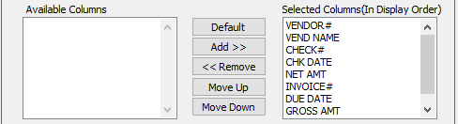

#### Available Columns

The user may choose which columns they wish to have on the report printout. As the user selects their choices, they will appear on the ‘*Selected Columns’* list.

#### Selected Columns (In Display Order)

The columns that the user has chosen from the ‘*Available Columns’* list. The order that these columns are displayed in here is the order in which they will print on the report.

#### Default

Click the ***“Default****”* button to sort the ‘*Selected Columns’* list by the default system parameters.

#### Add >>

Click on the selected item from the ‘*Available Columns’* list to highlight it, then click the ***“Add”*** button to add the selected column to the ‘*Selected Columns’* list.

#### << Remove

Click on the selected item from the ‘*Selected Columns’* list to highlight it, then click the ***“Remove”*** button to remove the selected column to the ‘*Selected Columns’* list.

#### Move Up

Within the ‘*Selected Columns’* list, the user may choose the order they wish the selected columns to print in. In order to change the order of the columns, the user can click on a selection to highlight it. By then clicking the ***“Move Up***” button, the user can change its position on the report.

#### Move Down

Within the ‘*Selected Columns’* list, the user may choose the order they wish the selected columns to print in. In order to change the order of the columns, the user can click on a selection to highlight it. By then clicking the ***“Move Down***” button, the user can change its position on the report.

### Output Destination

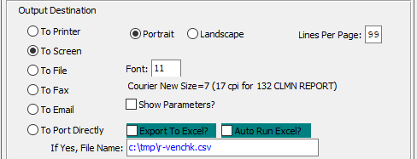

#### Destination Choice

To choose the destination where the document should be printed, please make sure that desired output destination choice bubble is toggled.

#### Layout Choice

To choose the preferred layout of Landscape vs. Portrait, please make sure the desired option choice bubbled is toggled.

#### Lines Per Page

Lines per page on the report when printing.

#### Font

Enter the font number to use with this report (Font 11 is default).

#### Show Parameters? – Toggle Box

To show parameters, make sure that the toggle box is ‘ticked’ with a checkmark.

#### Export to Excel? – Toggle Box

To export the printed file to an excel document, make sure that the Export to Excel toggle box is checked.

#### Auto Run Excel? – Toggle Box

To automatically open the new excel document, make sure that the Auto Run Excel toggle box is checked.

#### If Yes, File Name

If exporting the file to Excel, enter the desired file name.

## 1099 Miscellaneous [VR$]

### Selection Parameters

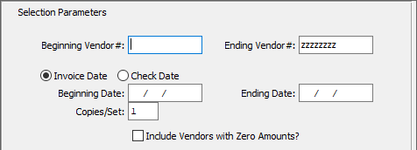

#### Beginning Vendor # / Ending Vendor #

Enter the beginning and ending Vendor Number to run the report for.

#### Date (Choice)

To choose the preferred date option of Invoice Date vs. Check Date, please make sure the desired option choice bubble is toggled.

#### Beginning Date / Ending Date

Enter the beginning and ending Date to run the report for.

#### Copies/Set

Enter a number of copies in this field.

#### Include Vendor with Zero Amounts? – Toggle Box

To include vendors with zero accounts in the 1099 report, make sure that this toggle box is checked.

### Output Destination

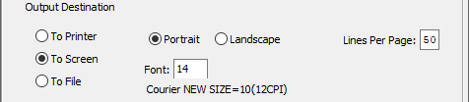

#### Destination Choice

To choose the destination where the document should be printed, please make sure that desired output destination choice bubble is toggled.

#### Layout Choice

To choose the preferred layout of Landscape vs. Portrait, please make sure the desired option choice bubbled is toggled.

#### Lines Per Page

Lines per page on the report when printing.

#### Font

Enter the font number to use with this report (Font 11 is default).

## Check Register by GL Number [VR%]

### Selection Parameters

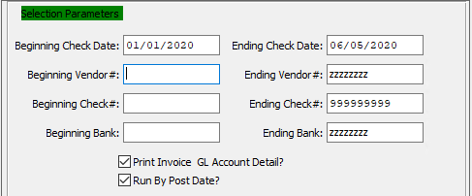

#### Beginning Check Date / Ending Check Date

Enter the beginning and ending Check Date to run the report for.

#### Beginning Vendor # / Ending Vendor #

Enter the beginning and ending Vendor Number to run the report for.

#### Beginning Check # / Ending Check #

Enter the beginning and ending Check Number to run the report for.

#### Beginning Bank / Ending Bank

Enter the beginning and ending Bank Number to run the report for.

#### Print Invoice GL Account Detail? – Toggle Box

To print an invoice’s General Ledger account detail on the report, make sure that this toggle box is checked.

#### Run by Post Date? – Toggle Box

To run the report by posting date, make sure that the Run by Post Date toggle box is checked.

### Output Destination

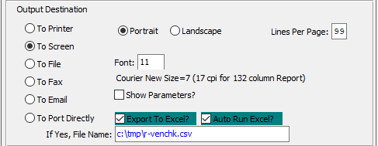

#### Destination Choice

To choose the destination where the document should be printed, please make sure that desired output destination choice bubble is toggled.

#### Layout Choice

To choose the preferred layout of Landscape vs. Portrait, please make sure the desired option choice bubbled is toggled.

#### Lines Per Page

Lines per page on the report when printing.

#### Font

Enter the font number to use with this report (Font 11 is default).

#### Show Parameters? – Toggle Box

To show parameters, make sure that the toggle box is ‘ticked’ with a checkmark.

#### Export to Excel? – Toggle Box

To export the printed file to an excel document, make sure that the Export to Excel toggle box is checked.

#### Auto Run Excel? – Toggle Box

To automatically open the new excel document, make sure that the Auto Run Excel toggle box is checked.

#### If Yes, File Name

If exporting the file to Excel, enter the desired file name.

# **File Maintenance for Vendors [VF]**

## Overview

The Vendor File program provides for addition, modification, and deletion of vendor information. To find a vendor, press the letter ***“N”*** for Next, ***“P”*** for Previous, or the ***“F”*** for Find. The ***“F”*** (Find) key provides the ability to type a few characters on the vendor # to search for the vendor.

The Terms file allows your company to define terms with net payment days and net discount days for each term. Once defined the terms may be used on the customer file and on invoicing procedures.

The Tax Codes file allows your company to list a group of tax codes so that taxable items will be multiplied by this tax rate. The reason for multiple tax structures would be for multiple groups such as city, state, and county taxes to be applied to an invoiced item. Another example would be a Canadian tax group such as PST and GST taxes applied to an invoiced item.

The Vendor Type file is a user defined grouping of vendors so that reports may be printed by vendor type.

The Buyer file is used to enter your company’s bank information such as name, address, account number, etc.

The Accounts Payable Control file is used to set the default Accounts Payable General Ledger accounts. This file must be set up prior to doing any Accounts Payable transactions. This account is used to hold your Accounts Payable liabilities.

## Vendors [VF1]

The vendor maintenance program provides for addition, modification, and deletion of vendor information. To find a vendor, press the letter ***"N"*** for next, ***"P"*** for previous, or the ***"F"*** for find. The ***"F"*** (Find) key provides the ability to type a few characters on the vendor # to search for the vendor. To add a new vendor, use the ***“A”*** (Add) key. Use the ***“O”*** (Notes) key to record any notes that may apply to a specific vendor. The ***“T”*** (Total) screen provides vendor period to date, year to date and last year information.

### Browse Vendors

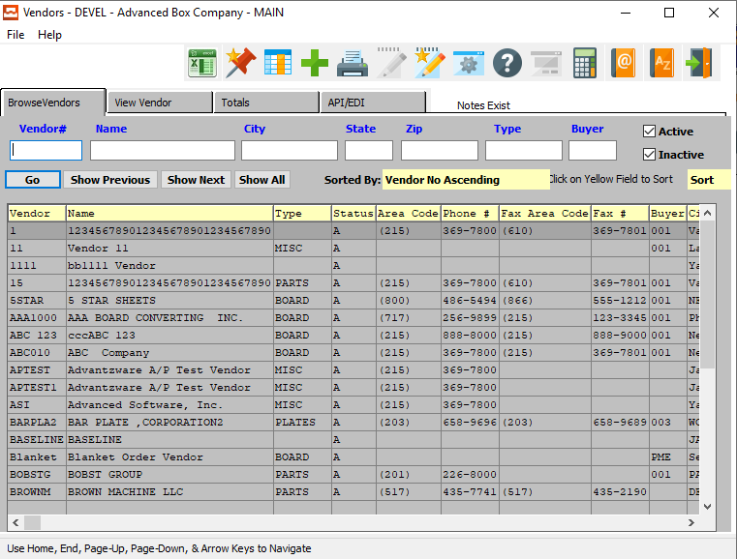

### Browse Vendors Field Definitions

#### Vendor #

Enter the vendor number, or press the ***"F1"*** key to search for an existing vendor.

#### Vendor Name

Enter the vendor name as you want it to appear on all A/P reporting.

#### City

Enter a vendor’s city to search for.

#### State

Enter a vendor’s state to search for.

#### Zip Code

Enter a vendor’s zip code to search for.

#### Type

Enter a vendor’s type to search for.

#### Buyer

Enter a vendor’s buyer contact name to search for.

#### Active – Toggle Box

To search for active vendors, make sure that the Active toggle box is checked.

#### Inactive – Toggle Box

To search for inactive vendors, make sure that the Inactive toggle box is checked.

### View Vendor

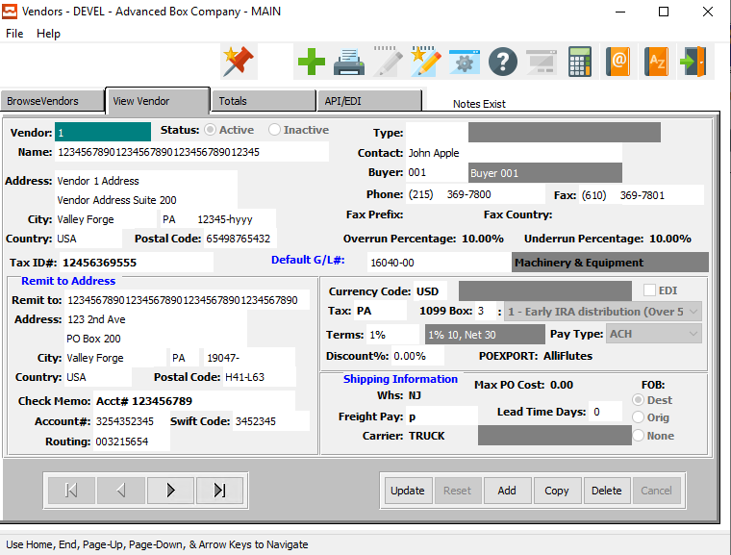

#### UPDATE

To change the currently selected vendor, simply click the ***“Update***” button at the bottom of the screen.

#### ADD

To add a new vendor, simply click the ***“Green + Icon”*** button at the top of the Vendors screen.

Alternatively, click the ***“Add”*** button at the bottom of the screen.

#### COPY

Click the ***“Copy”*** button to copy information from the currently selected Vendor.

#### DELETE

To delete the currently selected Vendor, simply press the ***"D"*** key. Alternatively, click the ***“Delete”*** button at the bottom of the screen.

#### NEXT

Press ***"N"*** (Next) to find next Vendor to view or modify. Alternatively, press the ***“Right Arrow”*** on the screen.

#### PREVIOUS

Press ***"P"*** (Previous) to find previous Vendor to view or modify. Alternatively, press the ***“Left Arrow”*** on the screen.

### Add/Update Vendor

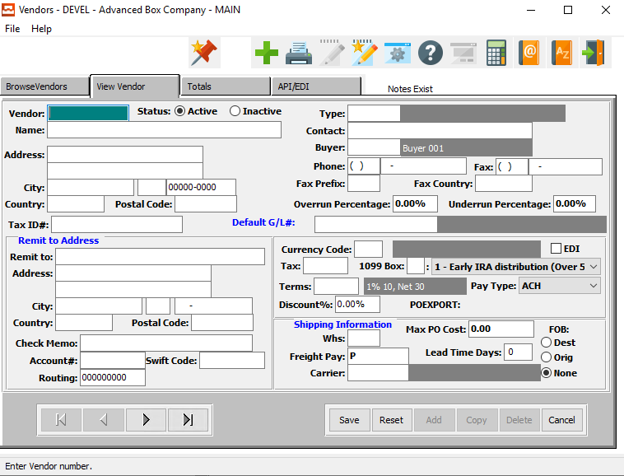

#### SAVE

Click the ***“Save”*** button to save all changes to the current Vendor.

#### RESET

Click the ***“Reset”*** button to reset all fields to their original state.

#### CANCEL

Click the ***“Cancel”*** button to cancel all changes to the Vendor without saving.

#### NEXT

Press ***"N"*** (Next) to find next Vendor to view or modify. Alternatively, press the ***“Right Arrow”*** on the screen.

#### PREVIOUS

Press ***"P"*** (Previous) to find previous Vendor to view or modify. Alternatively, press the ***“Left Arrow”*** on the screen.

### Add/Update Vendor Field Definitions

#### Vendor Number

Enter the vendor number, or press the ***"F1"*** key to search for an existing vendor.

#### Vendor Name

Enter the vendor name as you want it to appear on all A/P reporting.

#### Status (Choice)

To choose the preferred Vendor Status of Active vs. Inactive, please make sure the desired option choice bubble is toggled.

#### Address

Enter the first line of the vendor's address. Enter the vendor's second address line, if applicable. Enter the vendor's city. Enter the vendor's state. Enter the vendor's zip code.

Enter the vendor's country. You do not have to enter this field if both the vendor and your company have the same country.

Enter the vendors Postal Code, if located in Canada.

Make sure that it is the way you want it to appear on mailings. This address will appear on all Vendor correspondence.

#### Tax ID #

Enter the tax ID for this vendor. The user may enter a tax exempt number, if applicable.

#### Vendor Type

Enter a valid vendor type from the vendor type file. Press the ***“F1”*** function key to search and press ***“Enter”*** on selected item or press the ***“Page Up” or “Page Down”*** keys to scroll through vendor types. Entries in the vendor type file are user definable. This allows the company to customize vendor statistics.

#### Contact Name

Enter the name of your contact at the vendor company.

#### Buyer

Enter the buyer's 3 letter code from the buyer's file. Press the ***“F1”*** function key to search and press ***“Enter”*** on selected item, or press the ***“Page Up” or “Page Down”*** down keys to scroll through buyer codes.

#### Phone Number

Enter the vendors phone number including the area code.

#### Fax Number

Enter the vendor’s fax number including the area code.

#### Fax Prefix

Enter the fax prefix area code for this vendor.

#### Fax Country

Enter the country as in USA or CANADA.

#### Overrun Percentage

Enter the overrun percentage the vendor is allowed.

#### Underrun Percentage

Enter the underrun percentage the vendor is allowed.

#### Default G/L Number

Enter the G/L account number associated with the expense account used for this vendor. Press the ***“F1”*** function key to search and press ***“Enter”*** on selected item, or press the ***“Page Up” or “Page Down”*** keys to scroll through the G/L account numbers.

#### Remit To

Enter the vendor name as you want it to appear on A/P checks, and other Vendor check correspondence.

#### Remit To Address

Enter the vendor's address. This address will appear on checks, and other Vendor check correspondence.

#### Check Memo

Enter the check memo information. This information will print in the memo field of the printed check, if field is available on users check format.

#### Account #

Enter the account number for the vendor.

#### Swift Code

Enter the Swift Code for this vendor.

#### Routing Number

Enter the routing number for this vendor’s account.

#### Currency Code

Enter the currency code. To look up a code use the ***“F1”*** key to do a look-up of the codes that you are looking for.

#### EDI – Toggle Box

To mark this Vendor as using an Electronic Data Interchange, make sure that the EDI Invoice toggle box is checked.

#### Tax

The Tax Codes file allows your company to list a group of tax codes so that taxable items will be multiplied by this tax rate. The reason for multiple tax structures would be for multiple groups such as city, state, and county taxes to be applied to an invoiced item. Another example would be a Canadian tax group such as PST and GST taxes applied to an invoiced item.

#### Warehouse

Enter the warehouse code that the vendor ships from.

#### 1099 Box

Enter a code for this vendor (optional). This code will determine which type of 1099 to print during the year-end processing. For Example, a 1099 code of ***'N'*** stands for non-employee compensation, while a code of ***'R'*** stands for rent.

#### 1099 Box Definition

Valid Options for the 1099 Code are as follows:

|  |  |  |  |
| --- | --- | --- | --- |
| 1 | Early IRA Distribution (Over) | F | Charitable Gift |
| 2 | Early IRA Distribution (Under) | G | Direct IRA Rollover |
| 3 | Disability | H | Direct Roth Rollover |
| 4 | Death | J | Early Roth Distribution |
| 5 | Prohibited Transaction | L | Loans as Distributions |
| 6 | Section 1035 Exchange | N | Recharacterized IRA |
| 7 | Normal Distribution | P | Excess Contributions |
| 8 | Excess Contributions | Q | Qualified Roth Distribution |
| 9 | Life Insurance Cost | R | Recharacterized IRA |
| A | 10-Year Tax Option | S | Early Simply IRA |
| B | Roth Account Distribution | T | Roth IRA Distribution |
| D | Annuity Payments | U | ESOP Dividend |
| E | Distributions (EPCRS) | W | Qualified Long-Term Care |

#### Terms

Enter a valid terms code from the terms file. Press the ***“F1”*** function key to search and press ***“Enter”*** on selected item or press the ***“Page Up” or “Page Down”*** keys to scroll through terms codes.

#### Pay Type

The user may choose the vendor’s payment type from a drop-down list of available option. Valid Payment Types are as Follows:

|  |  |  |
| --- | --- | --- |
| ACH | Check | Paper |
| Bill Pay | Credit Card |  |

#### Discount %

Enter the vendors default discount percentage. The user can modify the default discount percentage when entering or editing the vendor invoice.

#### Max PO Cost

The amount entered allows you to limit the cost of a single PO. Once the PO Max is exceeded, there will be a pop-up to alert you and the PO will be put on "Hold".

#### FOB (Choice)

To choose the preferred FOB of Dest. vs. Original (Or None), please make sure the desired option choice bubble is toggled.

#### Freight Pay

Valid Freight Payment Codes are as Follows:

|  |  |  |
| --- | --- | --- |
| B | Billable | Vendor will invoice the customer for the freight. |
| C | Collect | A Third-Party Carrier will collect payment for the freight. |
| P | Prepaid | Vendor pays for the Freight Cost |

#### Lead Time Days

Enter the number of days that the discount is valid (default). The user can modify the default number of discount days when entering or editing the vendor invoice.

#### Carrier

Enter common carrier normally used for shipments from vendor. Press the ***“F1”*** function key to search and press ***“Enter”*** on selected item, or use the ***“Page Up” or “Page Down”*** keys to scroll through available codes.

### Totals

The Vendor Totals Screen shows the period to date, year to date, Last Year Purchases, Highest balance by date, the last payment and date, the total number of invoices paid and the average number of days to pay.

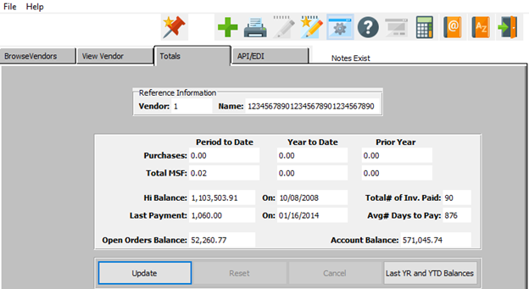

#### UPDATE

To change the currently selected Vendor Total, simply click the ***“Update***” button at the bottom of the screen.

#### LAST YEAR AND YTD BALANCES

To view and edit the current vendor’s balances from the last year, and the current year to date, click on the ***“Last YR and YTD Balances”*** button.

### Add/Update Total

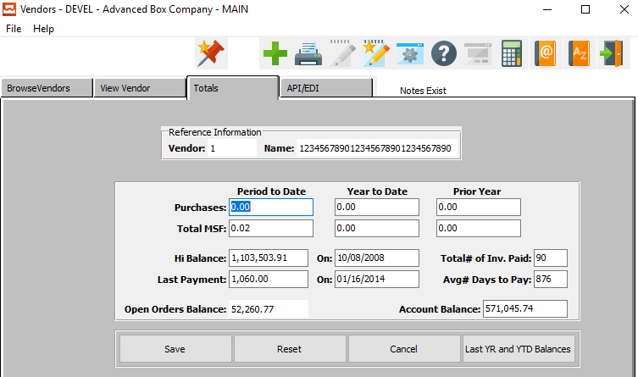

#### SAVE

Click the ***“Save”*** button to save all changes to the current Vendor Total.

#### RESET

Click the ***“Reset”*** button to reset all fields to their original state.

#### CANCEL

Click the ***“Cancel”*** button to cancel all changes to the Vendor Total without saving.

#### LAST YEAR AND YTD BALANCES

To view and edit the current vendor’s balances from the last year, and the current year to date, click on the ***“Last YR and YTD Balances”*** button.

Please Note: Only those who have higher access levels will be able to view or edit these balances.

### Add/Update Total Field Definitions

#### Period to Date: Purchases

Enter this Vendor’s total purchases from the period to date.

#### Period to Date: Total MSF

Enter this Vendor’s total MSF from the period to date.

#### Year to Date: Purchases

Enter this Vendor’s total purchases from the year to date.

#### Year to Date: Total MSF

Enter this Vendor’s total MSF from the year to date.

#### Prior Year: Purchases

Enter this Vendor’s total purchases from the prior year.

#### Prior Year: Total MSF

Enter this Vendor’s total MSF from the previous year.

#### Hi Balance

Enter the total balance of all purchases for this vendor.

#### Hi Balance On

Enter the last date that the total balance of this vendor was calculated.

#### Last Payment

Enter the total amount of the last payment this customer made.

#### Last Payment On

Enter the date on which this vendor made their last payment.

#### Total # of Invoices Paid

Enter the total number of invoices that this vendor has paid.

#### Average # Days to Pay

Enter the average number of days that this vendor takes to pay a new invoice.

#### Open Orders Balance

Enter the total balance of all of this vendor’s open orders.

#### Account Balance

Enter the current balance for the vendor account.

### API/EDI

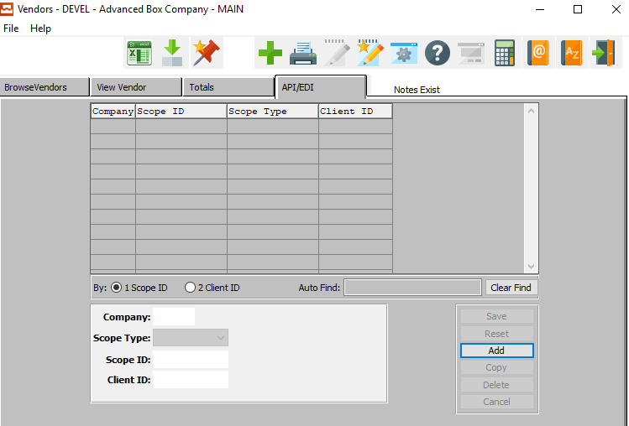

#### ADD

Click the ***“Add”*** button at the bottom of the screen to add a new API/EDI.

### Add/Update API/EDI

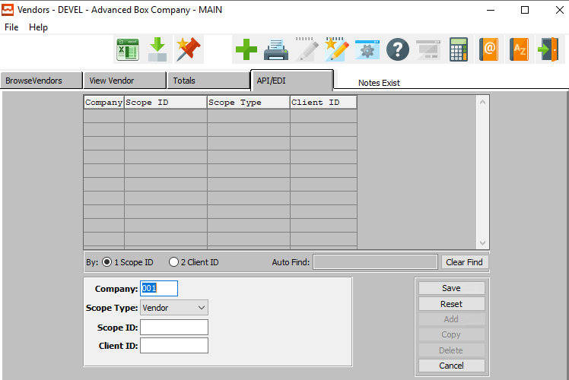

#### SAVE

Click the ***“Save”*** button to save all changes to the current API/EDI.

#### RESET

Click the ***“Reset”*** button to reset all fields to their original state.

#### CANCEL

Click the ***“Cancel”*** button to cancel all changes to the API/EDI without saving.

### Add/Update API/EDI Field Definitions

#### Company

Enter the company code for this Electronic Data Interchange.

#### Scope ID

Enter the scope ID for this Electronic Data Interchange.

#### Client ID

Enter the client ID for this Electronic Data Interchange.

## Vendor Types [VF4]

The Vendor Type file is a user defined grouping of vendors so that reports may be printed by vendor type.

### Browse Types

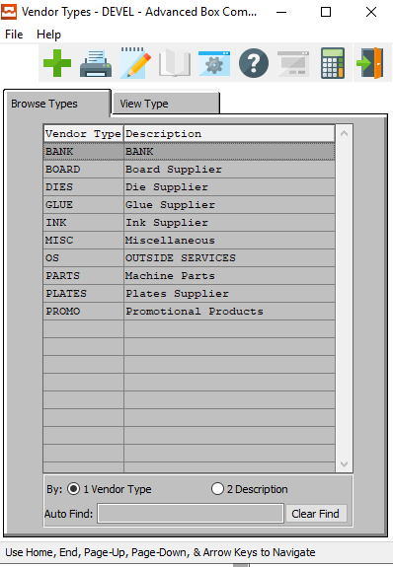

#### ADD

Click the ***“Green + Icon”*** to add a new Vendor Type.

### View Type

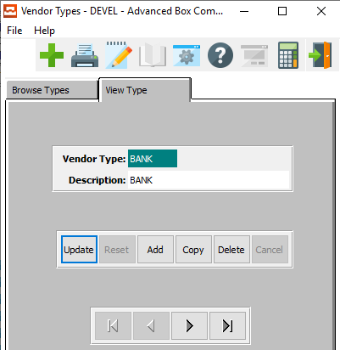

#### UPDATE

To change the currently selected Vendor Type, simply click the ***“Update***” button at the bottom of the screen.

#### ADD

To add a new Vendor Type, simply click the ***“Green + Icon”*** button at the top of the Vendor Type screen.

Alternatively, click the ***“Add”*** button at the bottom of the screen.

#### COPY

Click the ***“Copy”*** button to copy information from the currently selected Vendor Type.

#### DELETE

To delete the currently selected Vendor Type, simply press the ***"D"*** key. Alternatively, click the ***“Delete”*** button at the bottom of the screen.

#### NEXT

Press ***"N"*** (Next) to find next Vendor Type to view or modify. Alternatively, press the ***“Right Arrow”*** on the screen.

#### PREVIOUS

Press ***"P"*** (Previous) to find previous Vendor Type to view or modify. Alternatively, press the ***“Left Arrow”*** on the screen.

### Add/Update Type

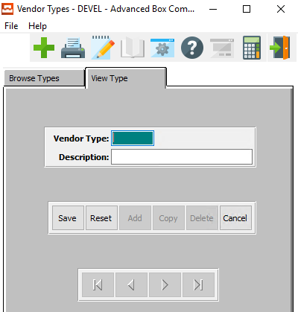

#### SAVE

Click the ***“Save”*** button to save all changes to the current Vendor Type.

#### RESET

Click the ***“Reset”*** button to reset all fields to their original state.

#### CANCEL

Click the ***“Cancel”*** button to cancel all changes to the Vendor Type without saving.

### Add/Update Type Field Definitions

#### Vendor Type

Enter a vendor type to describe this particular category of vendors.

#### Vendor Description

Enter a description to describe the vendor type.

## Buyers [VF5]

The Buyer file is used to enter all your company's buyers.

### Browse Buyers

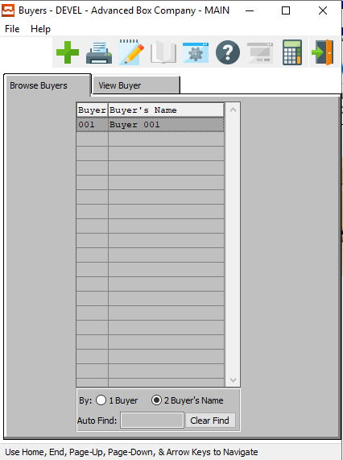

#### ADD

Click the ***“Green + Icon”*** to add a new Buyer.

### View Buyer

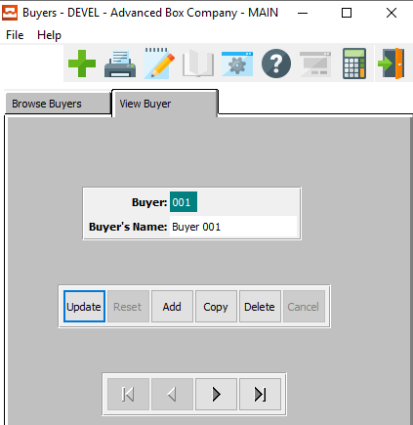

#### UPDATE

To change the currently selected Buyer, simply click the ***“Update***” button at the bottom of the screen.

#### ADD

To add a new Buyer, simply click the ***“Green + Icon”*** button at the top of the Buyer screen.

Alternatively, click the ***“Add”*** button at the bottom of the screen.

#### COPY

Click the ***“Copy”*** button to copy information from the currently selected Buyer.

#### DELETE

To delete the currently selected Buyer, simply press the ***"D"*** key. Alternatively, click the ***“Delete”*** button at the bottom of the screen.

#### NEXT

Press ***"N"*** (Next) to find next Buyer to view or modify. Alternatively, press the ***“Right Arrow”*** on the screen.

#### PREVIOUS

Press ***"P"*** (Previous) to find previous Buyer to view or modify. Alternatively, press the ***“Left Arrow”*** on the screen.

### Add/Update Buyer

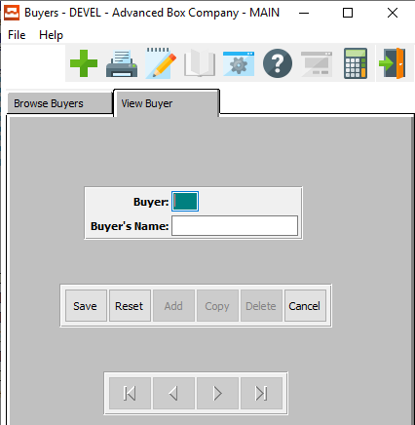

#### SAVE

Click the ***“Save”*** button to save all changes to the current Buyer.

#### RESET

Click the ***“Reset”*** button to reset all fields to their original state.

#### CANCEL

Click the ***“Cancel”*** button to cancel all changes to the Buyer without saving.

### Add/Update Buyer Field Definitions

#### Buyer Code

Enter the buyer's initials or code. This code can then be accessed in the vendor file maintenance when adding a new vendor.

#### Buyer’s Name

Enter the buyer's full name. This transfers to the vendor's file, when entering the buyer's code in the Vendor Maintenance program.

## Accounts Payable Control [VF6]

The Accounts Payable Control file is used to set the default Accounts Payable General Ledger accounts. This file must be set up prior to doing any Accounts Payable transactions. This account is used to hold your Accounts Payable liabilities.

### Accounts Payable Control Screen

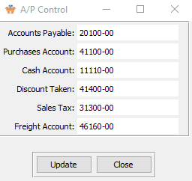

#### UPDATE

To change the control accounts, simply click the ***“Update***” button at the bottom of the screen.

#### CLOSE

Click the ***“Close”*** button to close the Control Screen.

### Update Control

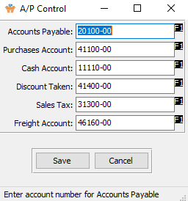

#### SAVE

Click the ***“Save”*** button to save all changes to the control accounts.

#### CANCEL

Click the ***“Cancel”*** button to cancel all changes to the control accounts without saving.

### Update Control Field Definitions

#### Accounts Payable Account

Enter the default Accounts Payable account number from the General Ledger chart of accounts. Press the ***“F1”*** function key to search for the G/L account.

#### Purchases Account

Enter the default Purchases account number from the General Ledger chart of accounts. Press the ***“F1”*** function key to search for the G/L account.

#### Cash Account

Enter the default Cash account number (G/L account for the default Bank Account) from the General Ledger chart of accounts. Press the ***“F1”*** function key to search for the G/L account.

#### Discount Taken Account

Enter the default Purchase Discount account number from the General Ledger chart of accounts. The Discount Account information is located in the G/L Accounts File, and accumulates Discount on Purchases.

Press the ***“F1”*** function key to search for the Discount G/L account number. It is important to remember, in the Vendor File, to choose the proper Discount Code (not to be confused with the G/L discount Account) for the Vendor. Examples of the Discount code are: Net 30 days, 2% 10 days net 15 days, and COD.

#### Sales Tax Account

Enter the Sales Tax account number from the General Ledger chart of accounts. Press the ***“F1”*** function key to search the G/L Accounts File.

#### Freight Account

Enter the Freight account number from the General Ledger chart of accounts. Press the ***“F1”*** function key to search the G/L Accounts File.

## Payment Type [VF7]

### Browse Types

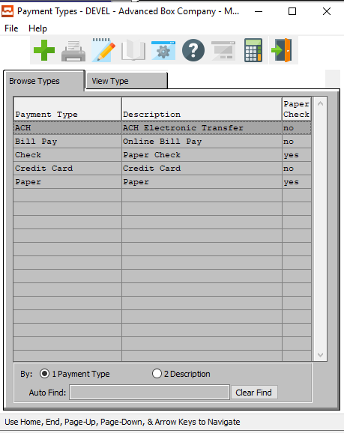

#### ADD

Click the ***“Green + Icon”*** to add a new Payment Type.

### View Type

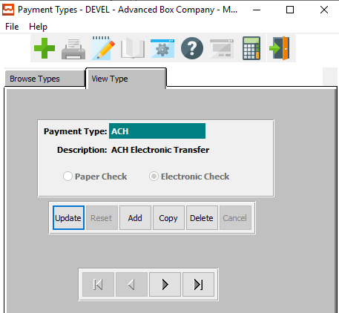

#### UPDATE

To change the currently selected Payment Type, simply click the ***“Update***” button at the bottom of the screen.

#### ADD

To add a new Payment Type, simply click the ***“Green + Icon”*** button at the top of the Payment Type screen.

Alternatively, click the ***“Add”*** button at the bottom of the screen.

#### COPY

Click the ***“Copy”*** button to copy information from the currently selected Payment Type.

#### DELETE

To delete the currently selected Payment Type, simply press the ***"D"*** key. Alternatively, click the ***“Delete”*** button at the bottom of the screen.

#### NEXT

Press ***"N"*** (Next) to find next Payment Type to view or modify. Alternatively, press the ***“Right Arrow”*** on the screen.

#### PREVIOUS

Press ***"P"*** (Previous) to find previous Payment Type to view or modify. Alternatively, press the ***“Left Arrow”*** on the screen.

### Add/Update Type

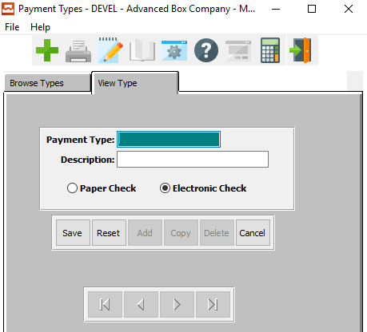

#### SAVE

Click the ***“Save”*** button to save all changes to the current Payment Type.

#### RESET

Click the ***“Reset”*** button to reset all fields to their original state.

#### CANCEL

Click the ***“Cancel”*** button to cancel all changes to the Payment Type without saving.

### Add/Update Type Field Definitions

#### Payment Type

Enter a code or small phrase for the payment type.

#### Payment Description

Enter a slightly more detailed description of the payment type.

#### Check Type (Choice)

To choose the preferred Check Type of Electronic vs. Paper, please make sure the desired option choice bubble is toggled.